**HLD**

**Network Protocols** – it defines the rules so two systems can communicate with each other.

🡺 **Client-server Protocol** - Communication is **initiated by the client**, which sends a request to the server. The **server waits for requests** and then responds to them. Ex- HTTP, FTP, SMTP, Web sockets.

🡺 **WebSocket** is a client server protocol that provides **full-duplex (two-way)** communication between a client and a server over a **single, long-lived TCP connection**.

It is useful in chat applications, live updates (stock prices, dashboards), collaborative tools (google docs-style editing)

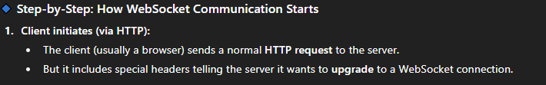

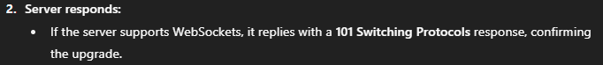

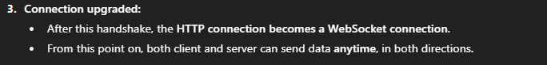

🡺 **HTTP** is an **application layer protocol** used for transferring web resources (HTML, images, videos, JSON, etc.) between a client (browser) and a server.

**Stateless:** Each HTTP request is independent; the server does not retain information about previous requests.

**Uses TCP:** Operates over **TCP/IP**, which is **connection-oriented**, ensuring reliable delivery of data. Connection oriented means where a **dedicated connection/session is established between two devices** before any actual data is sent.

Each HTTP request generally creates **one TCP connection** (HTTP/1.0).

HTTP/1.1 supports **persistent connections (keep-alive)**, allowing multiple requests/responses over a single connection. But requests are still handled sequentially. One request must finish before the next can be sent on that connection.

HTTP/2 and HTTP/3 support Multiplexing - allow multiple requests/responses to be **sent simultaneously** over a single connection.

Supports secure communication via HTTPS. (HTTP running **on top of TLS/SSL**) It ensures that data sent between your **browser (client)** and the **server** is **encrypted and secure**.

🡺 **FTP -** Enables file transfer between systems.

When you use FTP, it creates **two separate TCP connections** between the client and the server:

1. Control Connection –

* Created **first** when the client connects to the server.
* **Remains open** during the entire FTP session.
* Used to send commands — **not for file data**.

1. Data Connection –

* Created **whenever a file transfer or directory listing** occurs.
* **Closed after each transfer** — i.e., it’s temporary.
* Reopened when another file transfer is requested.

But it is not secure so we use HTTPS for file transfer in user-facing apps and websites. Server to Server transfer may use SFTP (SSH File Transfer Protocol)

🡺 **SMTP (Simple Mail Transfer Protocol):** used to send emails across the Internet.

**IMAP (Internet Message Access Protocol):** Enables email retrieval. Keeps emails on the server and syncs them across multiple devices.

**POP3**: Post Office Protocol V3 downloads emails from server to client.

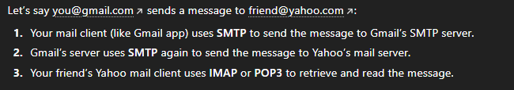

🡺 A **peer-to-peer (P2P)** protocol is a communication model where **each device (peer)** in the network can act as **both a client and a server**.  
There’s **no central server** controlling everything — instead, devices communicate **directly** with each other.

**WebRTC (Web Real-Time Communication)** is a **peer-to-peer technology** that allows **real-time audio, video, and data communication** directly between browsers or apps **without needing a central media server**. It uses UDP for low-latency transmission.

Uses signaling/STUN/TURN servers only for initial setup.

Used by – Google Meet, Discord, Whatsapp, YT live streaming, online multiplayer games, etc.

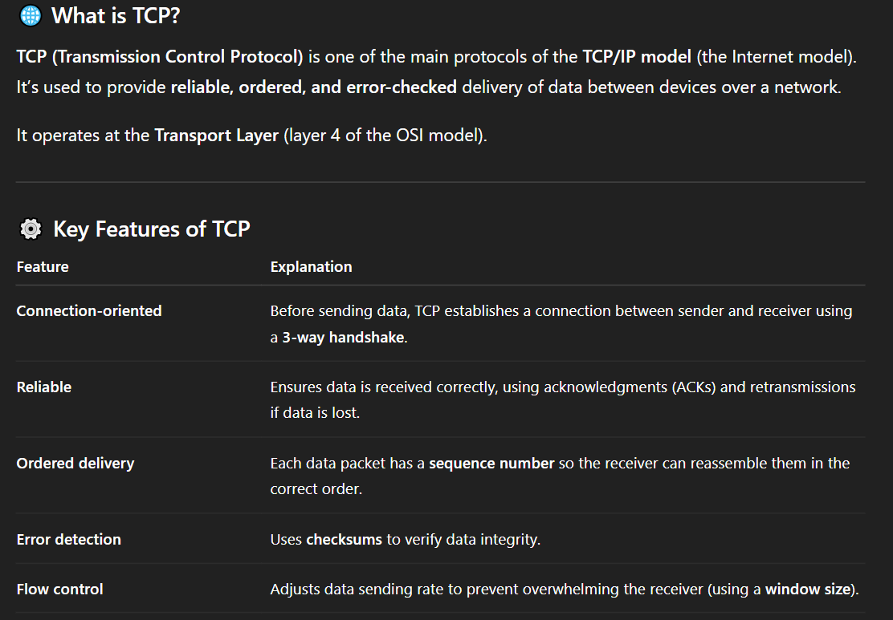

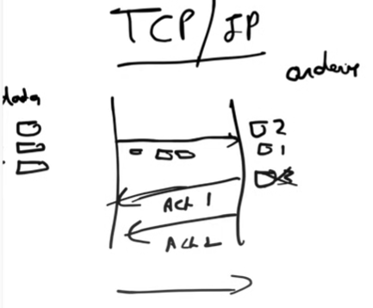

Checksum is used to verify that data wasn’t corrupted during transmission. Sender calculates the checksum on the segment data and adds it to the TCP segment header. When the segment arrives at receiver end, TCP performs **the same checksum calculation** on the received data. It compares the **calculated checksum** with the **checksum sent by the sender**.

**3 Way handshake** –

* Client sends SYN (synchronize sequence number) request to the server. Request message contains information like initial sequence number(x), SYN bit set to 1, and ACK bit set to 0.
* Server responds with an SYN-ACK message after receiving the client’s request. In response both ACK and SYN bits are set to 1 and server also sends random sequence number(y), and ACK’s acknowledgement number(x+1)
* Client sends an acknowledgment (ACK) to the server in which ACK bit set to 1, SYN bit set to 0 along with acknowledgement number (y+1)

🡺 **UDP (User Datagram Protocol)** is also a transport layer protocol. Data is divided into datagrams and each datagram is independent.

* **Connectionless:** UDP does **not establish a connection** before sending data. No handshake.
* **Reliability**: None – best efforts mechanism, packets may get lost, and no retransmission
* **Speed**: very fast as compared to TCP
* **Ordering**: Not maintained
* **Overhead**: Low

Used in live stream, video calling.

🡺 **CAP Theorem**

CAP is desirable property of distributed system with replicated data. But its impossible for a system to simultaneously guarantee all of them.

C – Consistency

A – Availability

P – Partition Tolerance

Ex- distributed system 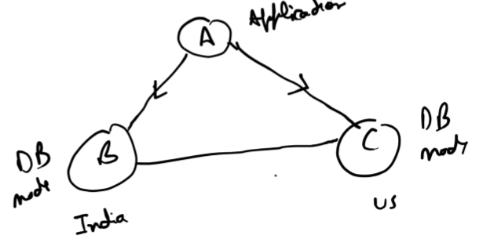

Application A can query DB node B or C. Basically DB nodes distributed across continents but they are syncing their data with each other (replicated data).

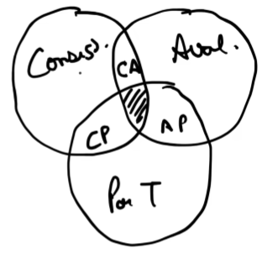 All 3 desirable properties cannot be achieved at the same time. We can only use 2 of them at the same time.

**Consistency** 🡪 suppose node B has data a=4, and A write to B to change a=5. Now B do successful write to it and changes a=5. Now after each write B will replicate the same data to C

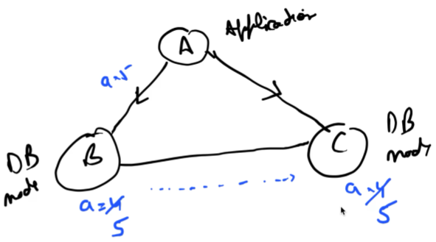 Consistency says that even though A write to B but when it tries to read value of ‘a’ from Db node C, then it should read the updated value 5 only.

After successful write to any node, if data is read from other nodes, then data should be same.

**Availability** 🡪 It says all nodes should always responds to client requests even if data may be stale.

**Partition Tolerance** 🡪 Overall system is hidden from user. He just knows to do query; he doesn’t know which DB node he is quering.

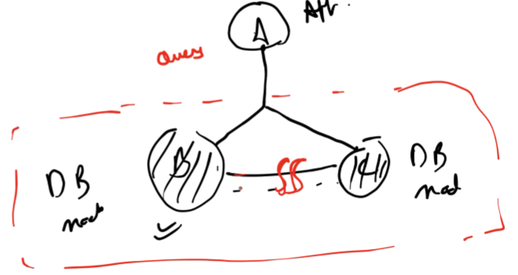

Inside the system if any communication breakage happens in DB node B and C and a network partition has been created but still if A is able to do query and getting response, then that is partition tolerance. Basically, System is UP.

**Why we can’t use them together?**

Let’s say my System has Consistency meaning if write happen to any db node, then I should read same data from all nodes. POSSIBLE

Availability is also possible that querying any node should respond.

Now check if my system has Partition Tolerance, will Consistency & Availability still exist?

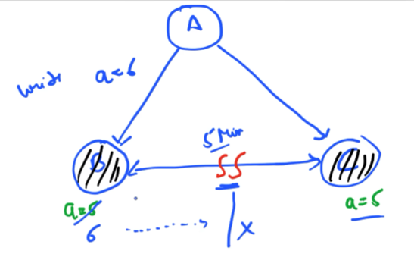

Suppose A writes to DB node B to change ‘a’ from 5 to 6 and B writes to it and try to sync data with DB node C. But becoz of parition toleralance let’s say there is network breakage for 5minutes, then for these 5 minutes node C will not get the updated value of ‘a’ and System is inconsistent.

* At the time of parition, Consistency is not possible.

CA – Is can be achieved if we drop Partition tolerance meaning if any network breakage happens then our System will go Down and requests will not be fullfilled. Its becoz if A tries to write to any DB node, then it won’t be able to sync data that’s why we can’t allow it and system needs to go down untill breakage resolve.

CP – To prevent returning stale data, DB node C should reject requests until the partition heals. Internally all requests will be fullfilled by node B. System is still UP, consistency maintained and parition tolerance is also there. We have to drop availability and some clients may see errors or timeouts.

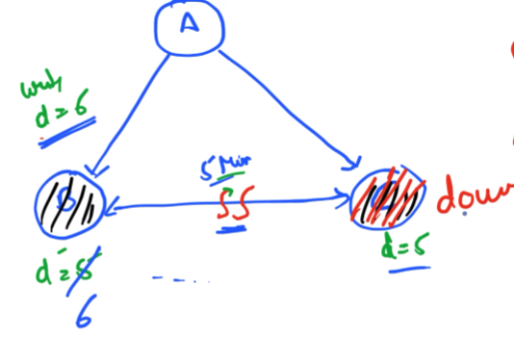

AP – if we drop Consistency, then it is possible. Both nodes available and partition tolerance. System is UP.

In real world, Parition tolerance is very much required so never trade off with it.

🡺 **Microservices Design Patterns**

**Monolithic application** is a **single, unified software application** where all components are **tightly coupled** and run as a single process.

Disadvantages –

* Overloads IDE
* Scaling is very hard – you have to scale the entire app not just the part that needs it.
* Tight coupling – changes in 1 module can break others.
* Hard to maintain – as codebase grows it becomes complex.
* Slow deployment – even small changes require rebuilding & redeploying the whole app

**Microservices** is an architectural style where an application is built as a **collection of small, independent services**, each responsible for **one specific functionality**.

We can distribute a big application into multiple services –

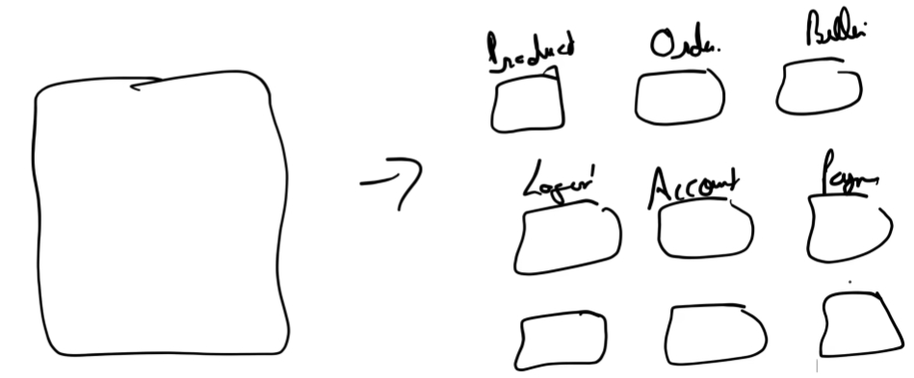

Advantages –

* If some bug occurs, then only that particular service will be fixed/debug/deployed.
* Managing the components becomes very easy for developer.
* Scale only the services that need more resources, Ex- order service during festive season
* Fault Isolation – failure in one service doesn’t crash the whole system
* Technology flexibility – diff services can use different programming languages, databases or framework
* Faster development – team can work on different services in parallel

Disadvantages –

* If the monolithic app is not properly divided into microservices, then it might cause latency issues. Each service should be loosely coupled otherwise a lot of communication will happen between services.
* If new code changes are made in a Service and deployed, then it can break clients which will consume the APIs of the service which got changed.

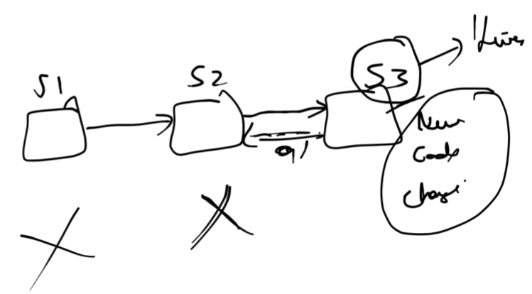

Something changes in behaviour of S3 will break S2 & S1.

Debugging becomes Hard, as if S1 break their engineer will say its due to S2, then S2 team engineer say we got failed due to S3 team, then it goes to S3 team and fixed. So by looking at the error it’s difficult to say who is the culprit.

Monitoring is slight difficult in MS as all the other clients also need to be monitored.

* Transaction Management is difficult. (ACID properties must fullfilled)

If there is single DB then it’s easy to start the transaction and commit it.

But in MS architecture, each Service has its own DB and runs independently. So, when one service updates its data and another fails, you can’t just “rollback” across multiple databases — there’s no global transaction manager.

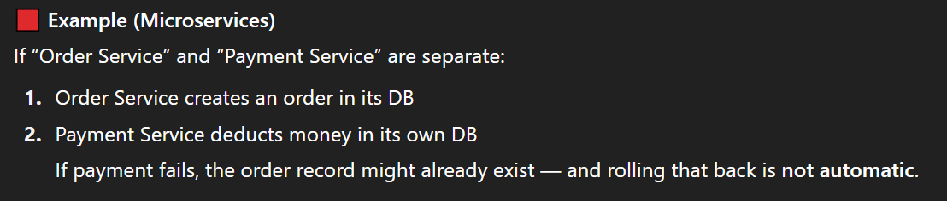

* End to end testing is harder across multiple services.

🡺 Microservices has differnet phases – Decomposition, Database, Communication, Integration, Deployement, Observability & Monitoring

* **Decomposition** – how small should a service be?

2 ways –

Decompose by business capability

Decompose by subdomain.

* **Database Design** – decide whether to pick separate database per service or shared DB
* **Communication** – via APIs or events
* **Integration** – decide how they will be integrated with user interface. Use an API Gateway

**Decomposition Pattern**

1. **Decompose by Business functionality / capability**

Break the system into services that represent **business functions**.

Ex- In online order application, businesss functionalities are - order management, product management, account management, login, billing, payment. Make them separate service.

Challenge - good knowledge about business functionality/capability

Works well for medium or smaller projects where boundaries are clear.

1. **Decompose by subdomain (DDD)**

Here we divide our Project into multiple domains and each domain can have multiple microservices.

Ex- Project is Online order application and Order management is a domain.

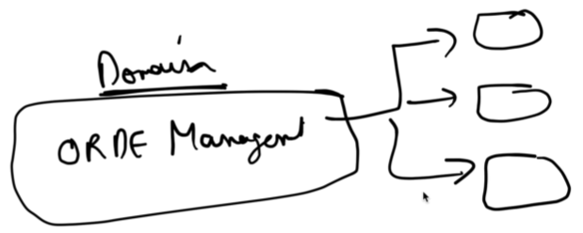

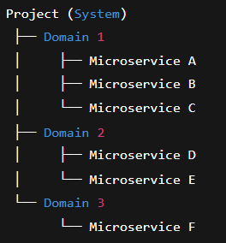 Domain Driven Design works better for large, complex systems where a single business function like “orders” might be too big to be one microservice.

**Strangler Pattern**

Used when refractoring monolithic application to microservices.

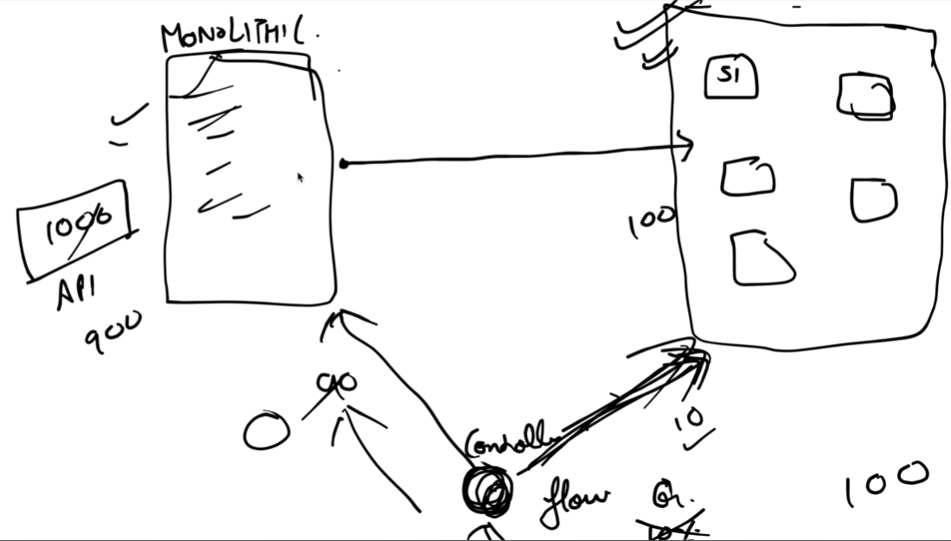

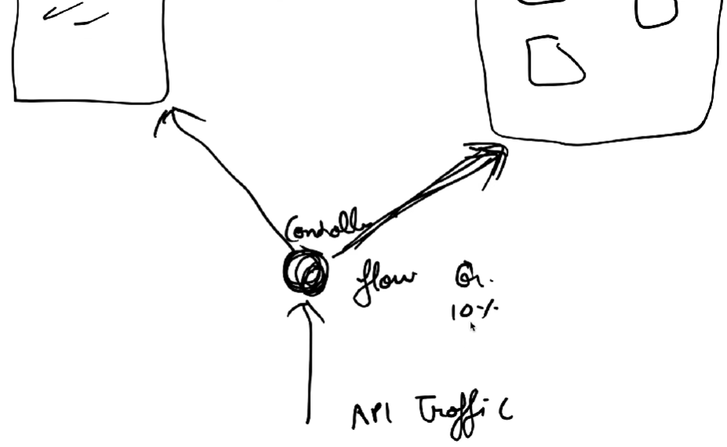

It is a **migration strategy** used to gradually move from a **monolithic architecture** to **microservices** — *without rewriting everything at once.*

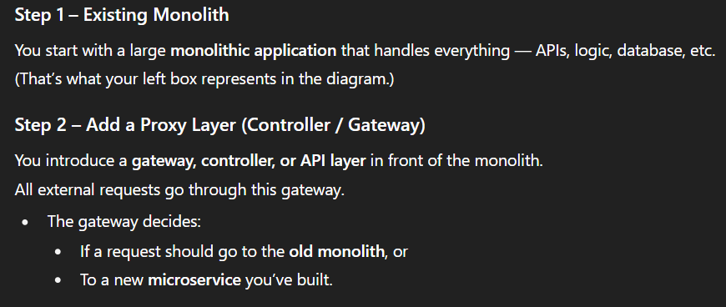

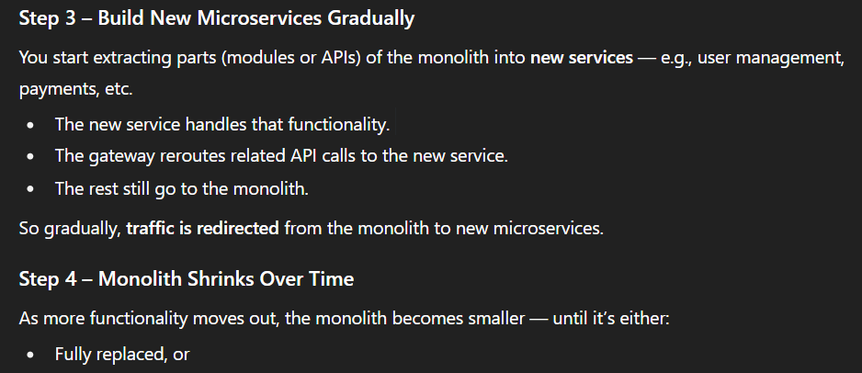

Benefits –

* Gradual migration - No big-bang rewrite; done safely, step by step
* Low risk - You can test and move one part at a time
* Continuous delivery - You don’t need to stop business operations
* Flexibility - Some parts can stay monolithic if needed

Challenges –

* Temporary complexity - For a while, both monolith and microservices coexist
* Data consistency problem - If an API updates data in the microservice DB but not in the monolith (or vice versa)

**Data Management in Microservices**

1. **Multiple MS share a single DB**

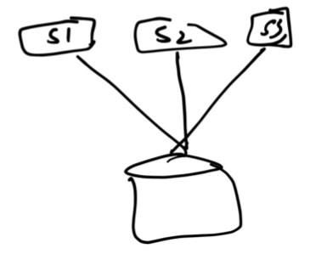

But this approach is not much successful –

* S1 (Order Service) gets heavy traffic — lots of orders are being placed. S2 (Inventory) and S3 (Payment) are relatively light.

Now, if all three share one common DB, and you need to handle S1’s load:

You can’t just scale S1’s database part independently. You must scale the entire shared database (which also includes Inventory & Payment tables).

It increases cost and you’re wasting resources scaling unused parts.

* If S3 want to delete a column in Table10 then it can’t do this directly because DB is also shared between S1 and S2. Before making a change, you must – check all other services code for dependencies and update them together.

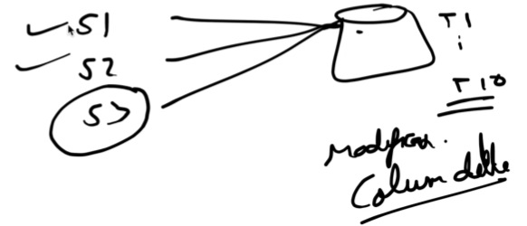

* If the shared DB goes down, *all* services are affected — tight coupling creates a single point of failure

Benefits –

* U can write easy JOIN query, useful when u need data from multiple domains
* Simpler transaction management – use native database transactions (ACID) no need for distributed transactions (SAGA pattern or two-phase commit)

1. **Database for each individual service**

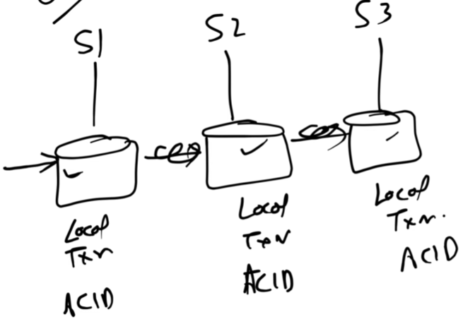

Each microservice can run its own local transactions inside its own DB and maintains its ACID property.

If a request spans multiple microservices, each with its own database, we cannot use a traditional SQL transaction to ensure ACID guarantees across all of them — because ACID properties apply only within a single database.

Challenges –

* when a transaction is spanning over a distributed DB. It is solved by SAGA pattern.
* Join query is not possible if tables are in separate DB. It is solved by CQRS.

There is an agrement that no service can query on the database of other service. All communication happens via APIs.

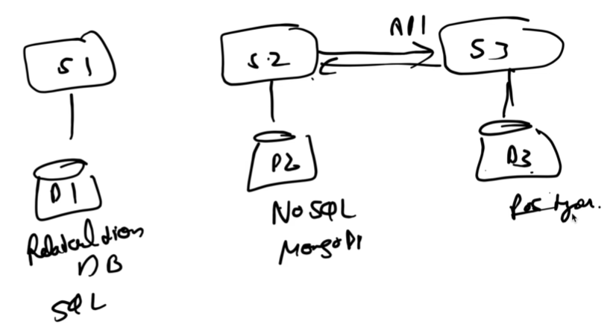

Benefits –

* Maintaining the database becomes easy as only 1 service is owning it.
* If load is increase on a particular Service Database, then it can be scaled independently to handle more transactions or store more data.
* If one service’s database crashes or is corrupted, **other services continue working**.
* Technology flexibility – each service can have different DB for each use case.

**SAGA Pattern** - used to manage distributed transactions in microservices architectures

Suppose a transaction comes 🡺 **Place an order** where are the DBs of Order, Inventory and Payment Service needs to be updated

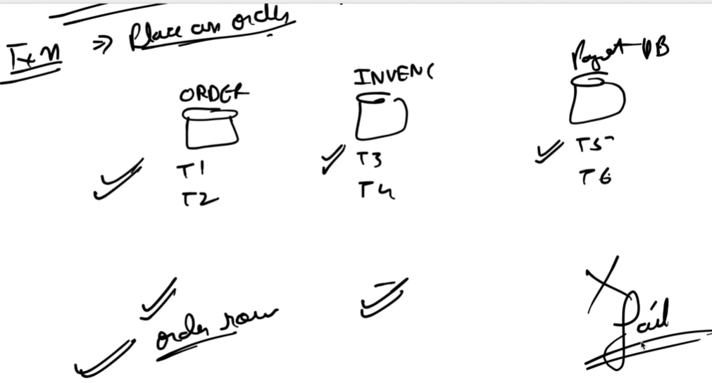

Consider scenario that Order & Inventory DB are updated but Payment DB operation fails.

ACID property says that whether all should get success or none. It should rollback. But due to multiple DB automatic rollback cannot happen.

**SAGA – Sequence of Local Transactions that maintain data consistency in distributed system**

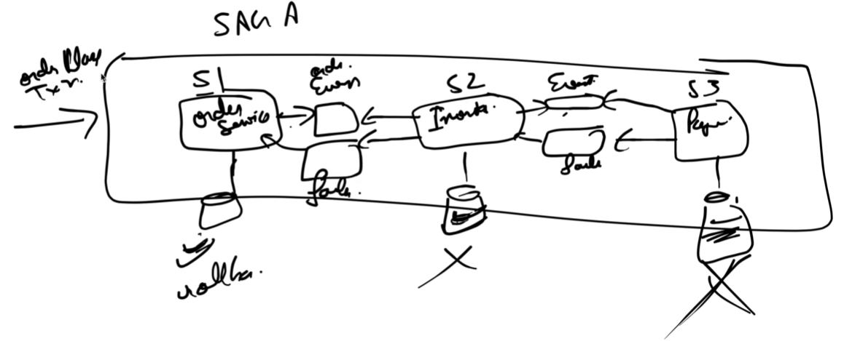

**S1-order service:** Starts when an Order Place Transaction arrives. Performs its **local transaction** (e.g., saves the order to DB). If success 🡪 OrderCreatedEvent is published. If failure 🡪 rollback locally.

**S2 – Inventory Service**: **Listens** to OrderCreatedEvent. Performs its **local transaction** (e.g., reserve stock). If success 🡪 Publishes an **InventoryReservedEvent**.

**S3 – Payment Service**: **Listens** to InventoryReservedEvent. Attempts to **process payment** (local transaction). If success → saga completes successfully. If failure (e.g., payment declined) → publishes **PaymentFailedEvent**.

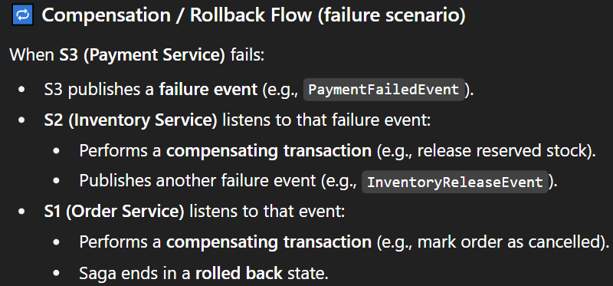

**SAGA pattern is of 2 types** –

1. **Choreography Based** – After S1 processes the updates, it publishes an event. S2 will listen that event and work on it. After it finishes updating, it will also publish event. S3 will listen to that event and start working on it. After it fails then S3 publish failure event which S2 will listern and rollback and so on…

**Event-driven** (no central coordinator) :- Basically each Service is listening to events and working on that basis.

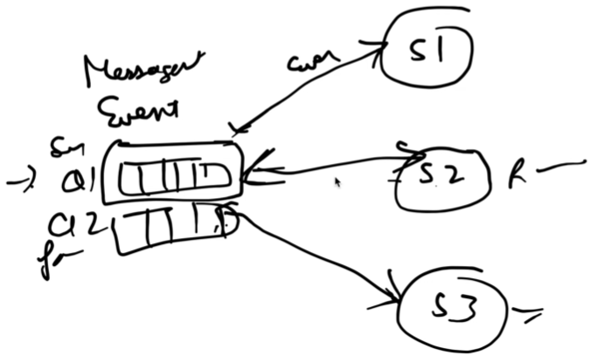

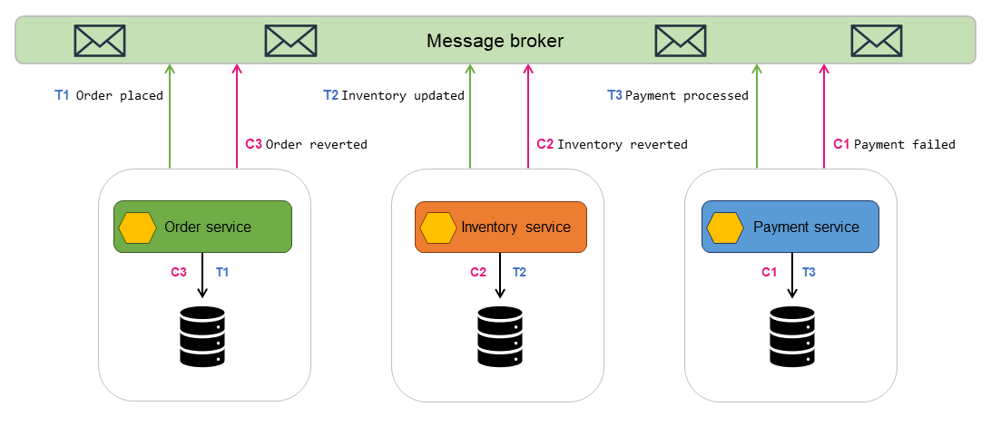

Drawback –

Cyclic dependency: If services start reacting to each other’s events, a loop may form. S1 publish event for S2 and vice versa in loop.

1. **Orchestration Based** –

A central orchestrator controls the flow of the saga. Each service just performs tasks and returns success/failure to the orchestrator.

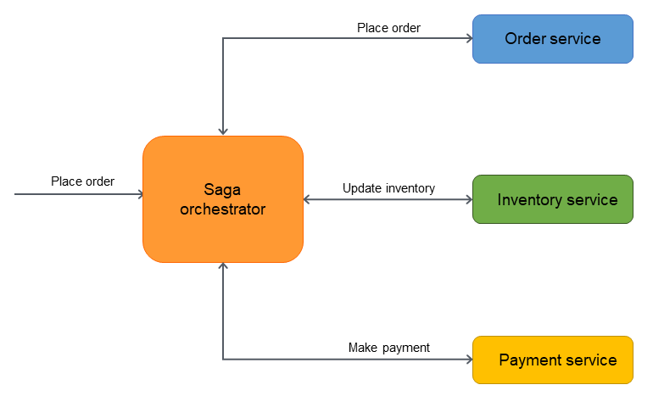

Orchestrator starts the saga. It will call S1. If success from S1, it will call S2. Then it will call S3. If S3 fails, now orchestrator will make sure that it calls S2 to perform its compensating transaction. After that it will call S1 to do the rollback order creation.

Centralized control of the entire saga – easy to visualize and monitor.

**Drawback** –

Tight coupling as Orchestrator must know which service to call, what API endpoints, in what order, how to handle responses.

If any service code changes 🡪 orchestrator must be updated.

Q: Suppose Person A pays 10 Rupees to Person B. Balance service deducts the amount but Payment service fails. How will u handle it?

Ans: Using SAGA pattern –

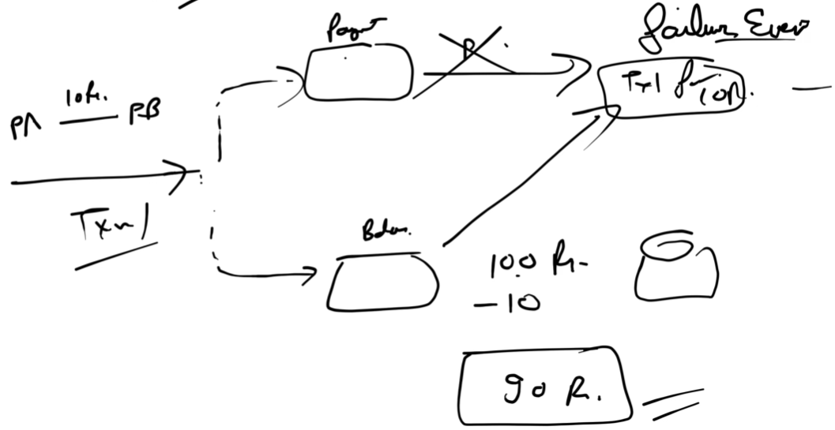

Balance service will listen to the failure event and do the compensation transaction to increment the balance by Rs 10.

**CQRS Pattern** (Command Query Request Segregation)

It’s a **design pattern** used in microservice to **separate write operations from read operations**.

* **Command side →** performs **Create, Update, Delete (CUD)**
* **Query side →** handles **Read (select)**.

**The Problem It Solves –**

* In microservice architecture: Each service (say S1: Orders, S2: Inventory) has its own database. So, when you want to do a join query (e.g., “get orders with product details”), you can’t directly join across DBs — that would break service isolation.
* 👉 CQRS solves this by maintaining a separate view database that holds combined data from multiple services.

Each service will do C, U, D operations on their own DB but all read will happen from common separate database. This View DB will have data from both table1 and table2. Now we can do join queries easily.

To update the View DB, it uses Events. Whenever a CUD operation happens then it publishes an event and View DB will listen to that event and update it. Instead of events we can also use DB Trigger/ Procedure to perform same operation in View DB after it happens in individual MS DBs.

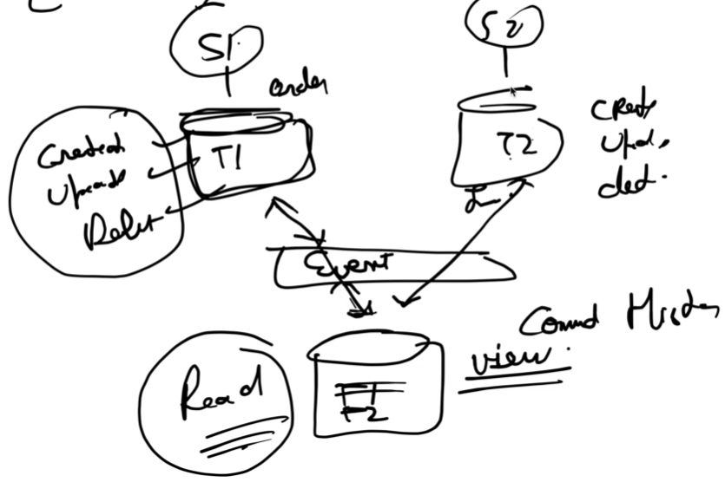

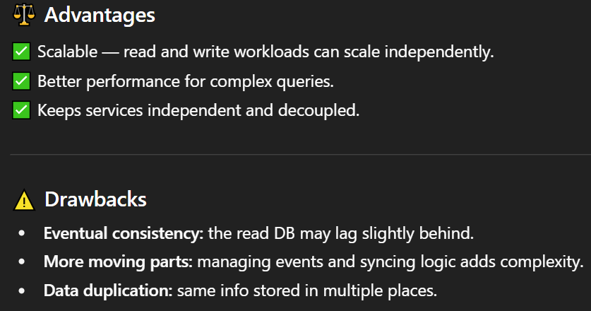

**Scale From ZERO to MILLION Users**

* Single Server
* Application & DB server seperation
* Load Balancer + Multiple app servers
* Database replication
* CACHE
* CDN
* Data Centre
* Messaging Queue
* Database Scaling

**Single server –** it’s like the project that we made in college where there are 0 users. Client is Web/Mobile. Client directly talks to the server. Application and DB both are in same server.

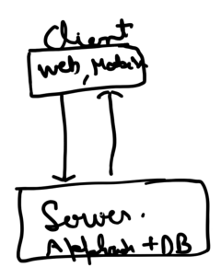 we hosted the DB inside same server.

**Application & DB server seperation –** we need to introduce a Mid tier layer where we host our Application in server whose responsibility is to only run business logic. Application server talks with DB server.

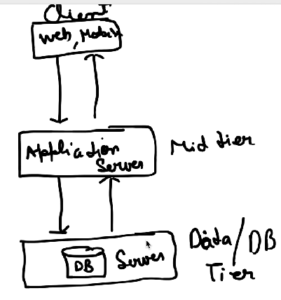 It is needed so we can scale our App and DB independently so we removed tight coupling.

**Load Balancer + Multiple app servers** – A single app server has limited CPU, memory and network bandwidth. As more users send requests, the server’s capacity will max out. To handle more traffic, we need to add more app servers.

Client can’t talk to multiple App servers directly so we need a layer between – Load Balancer.

Client talks with LB and LB forward the request to one of the app servers based on load. It tries to equally distribute the laod.

LB also brings little bit security & privacy as LB and App servers talk in private IP. Client on internet now cannot call directly application server.

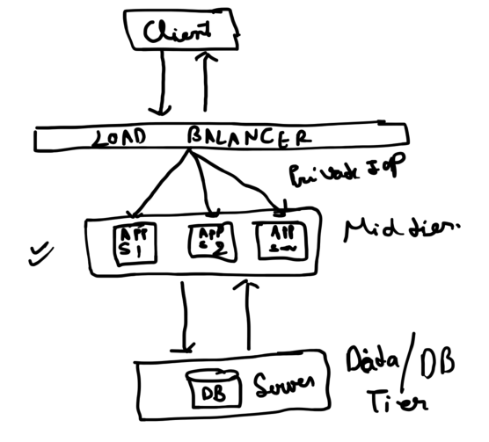

* You get **high availability** and **fault tolerance.**
* No single point of failure.
* Throughput (no of requests processed per second) increases.
* With multiple servers: You can update one server at a time while others keep running (rolling deployment) without impacting users. In K8s, it updates pods gradually.

Benefits of rolling deployment –

🡪 **Zero or minimal downtime**

**🡪 Gradual rollout** – u can monitor performance can catch issues early before all servers are updated

**🡪 Easier rollback -** If something goes wrong, you can quickly roll back affected servers to the previous version while others remain stable.

**Blue-Green Deployment** – It is a strategy for releasing new versions of an application by running **two identical environments** — one active (“blue” which is live) and one idle (“green”).

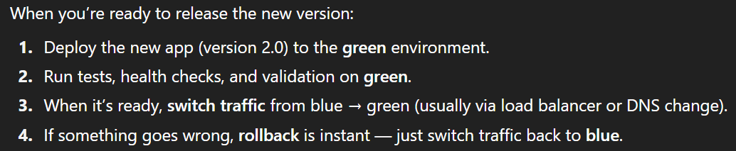

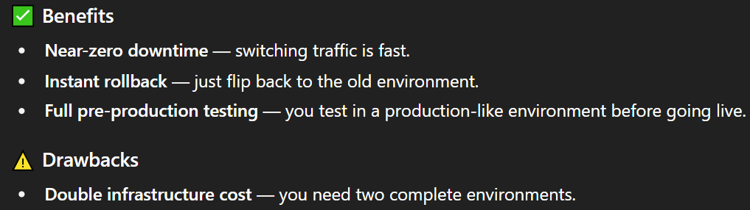

**Database replication –** we’ll have multiple slave DBs and 1 master DB. All write requests go to Master DB and all read will happen from slave DB. Each slave DB keep their data copies synchronized with master DB.

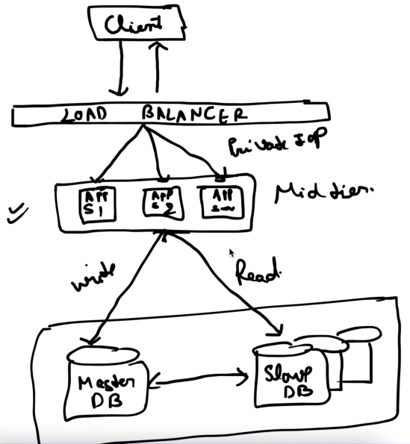

Benefits –

* High availability – Even though 1 slave DB fails, my system will not go down as I have replicas.
* If my master DB fails then any of the slave DB will get promoted to master DB.
* Performance – faster reads and reduced load on master
* Scalability – distribute read load across multiple slaves

Drawback – Replication lag: Slaved might be slightly behind the master.

**CACHE** – Storing frequently accessed data in a fast, in-memory layer (like Redis or Memcached) so that your app doesn’t have to query the database every time.

whenever our app server talks with DB every time, it’s a network call which is expensive. Before going to DB, we can first check in cache is data is present.

If data is present 🡪 Cache Hit

If not present 🡪 Cache Miss, now go to DB -> Save fetched data with TTL –> return value

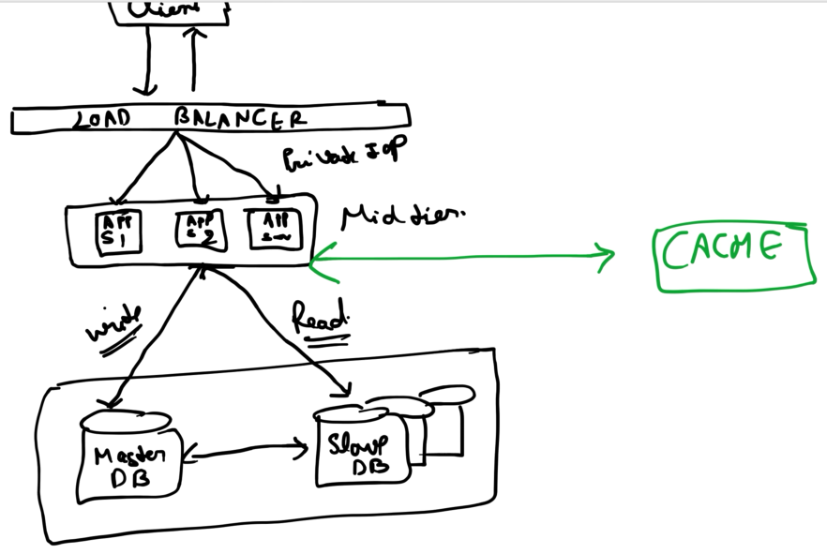

As soon as the TTL expires, data in cache will get purged.

Benefits –

* Better user experience – low latency, faster response
* Reduced DB load
* Improved availabiliy – cache can still serve data if DB is temporarily slow.

**CDN (Content Delivery Network)**- It is a globally distributed network of **servers** that deliver **web content (static files)** to users from locations **closest to them** — instead of always fetching it from your main/origin server.

Suppose ur app is working well in India and now foreign users also started coming. If ur data centre is only in India, then Indian users can access app very fastly as the request/response travelling time is low. But users from other countires will take more time as distance from data centre increases.

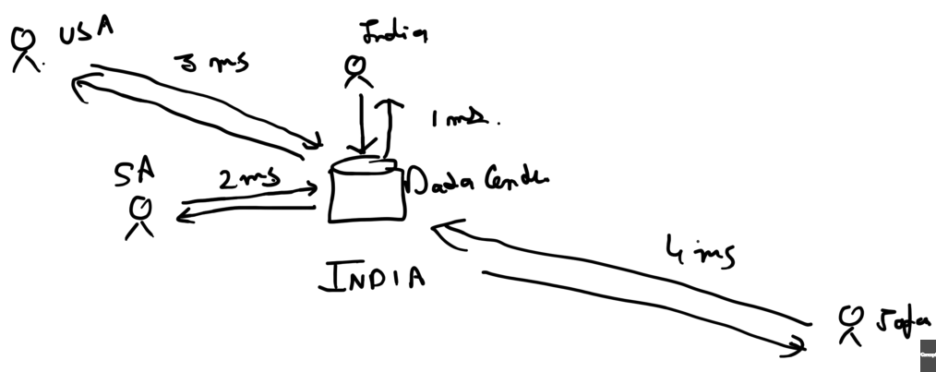

As our users are all over the world, we are getting latency issues which is solved by CDN. We can setup CDN node in each country. CDN does caching of static data (html, images, video, css)

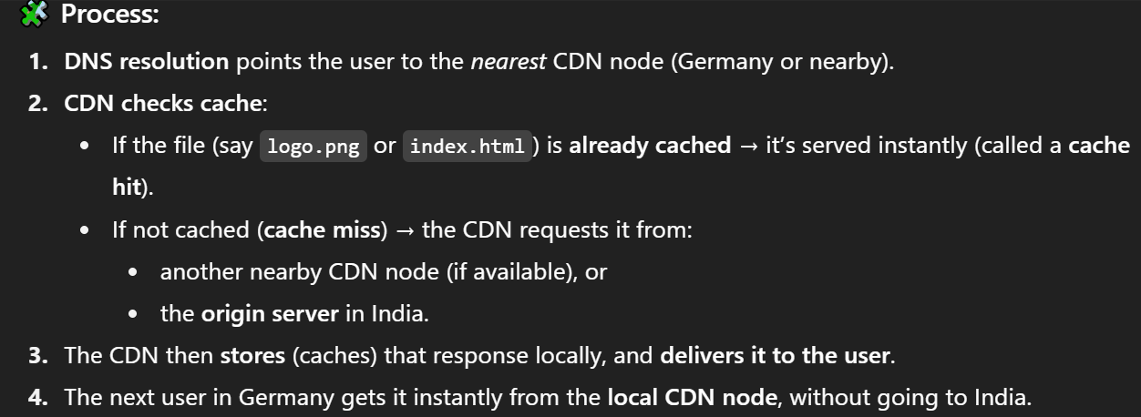

Benefits –

* Performance increases
* Security as traffic is not directly coming to original server. Hides your origin IP.
* CDN is intelligent enough to identify attacks like DDoS (Distributed Denial of Service) where multiple bots flood an API or website with so much traffic/requests that it becomes slow, unresponsive or completely unavailable to real users.
* Load reduces on original server
* Cost cutting as less db servers needed to handle huge traffic.
* High availability - If one node goes down, CDN reroutes to another healthy node.

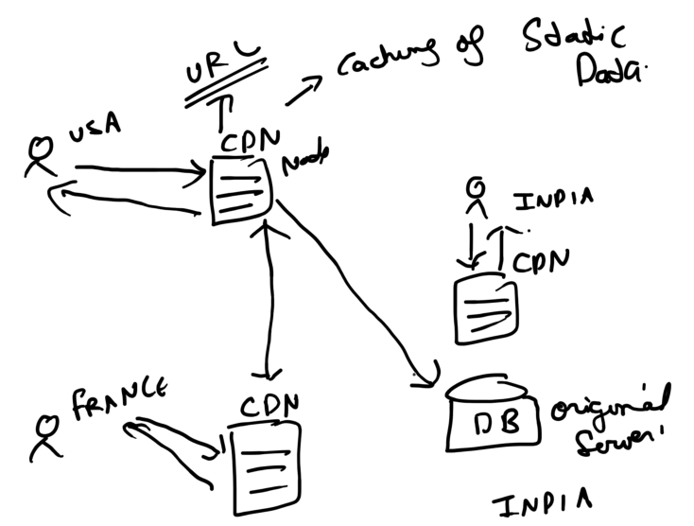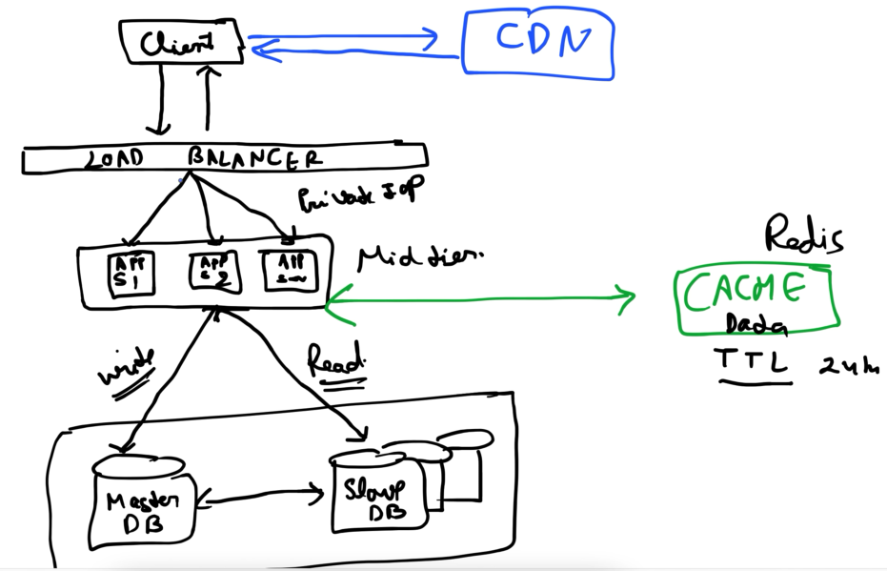

**Data Centre**

Currently my App and DB servers are in India but I can have more data centres.

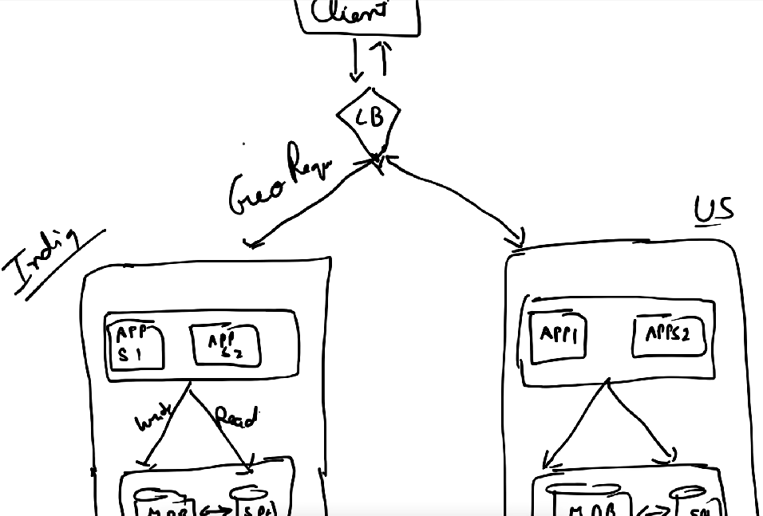

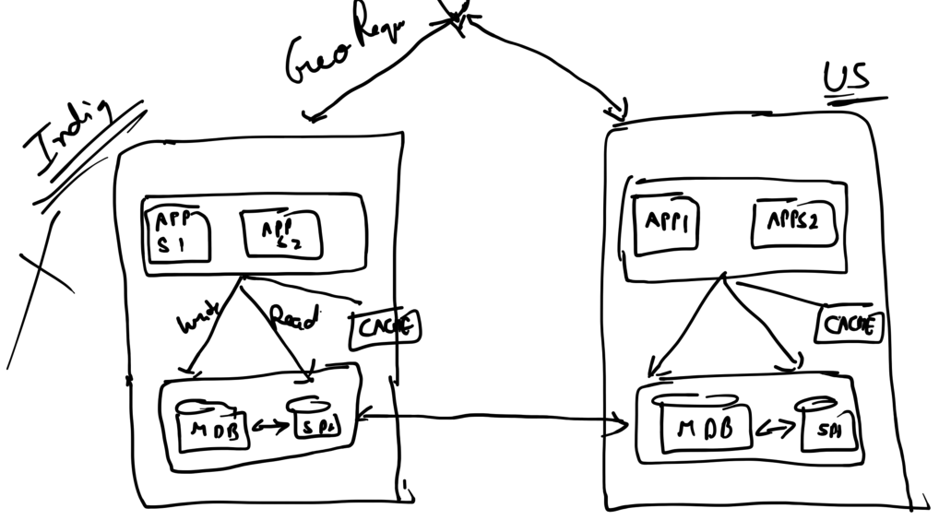

Global Load Balancer based on the Geo request can route requests to the nearest data centre.

DB replication happens across Geos.

Benefits –

* Suppose India data centre goes down then LB will fullfill all requests from US data centre.
* Load reduces on each data centre
* Low latency – users connect to the nearest servers.
* Scalability – u can add more regions as your user base grows.

**Messaging Queue** – RabbitMQ, Kafka

Producer pushes the message in MQ and there are different Subscribers who read the message from Queue and processes them. It brings async nature in our codebase.

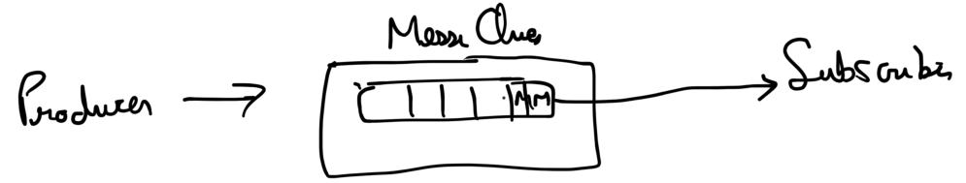

Ex- sending email can be done async.

If the Subscriber fails to process the msg, then MQ can requeue the msg.

**RabbitMQ –** It is a **message broker** that routes messages from **Producers** to **Consumers** using Exchanges, Queues, and Bindings.

Producer: sends the message to an Exchange. Attaches a Routing Key to the message.

Exchange: a component that receives messages from producers and routes them to one or more queues based on a set of rules called bindings. It uses routing key from Producer and compares it against binding keys defined by queues.

Binding key is a parameter used when you create a binding between an exchange and a queue.

Queue: where msgs are stored until a Consumer reads them. Each queue can have multiple consumers.

Binding: are rules that tells an exchange which messages to send to a particular queue.

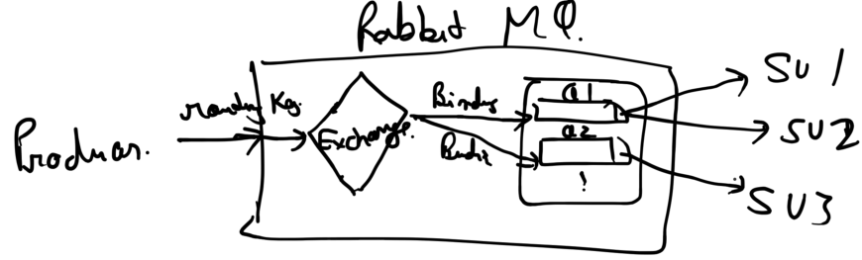

Different types of Exchange –

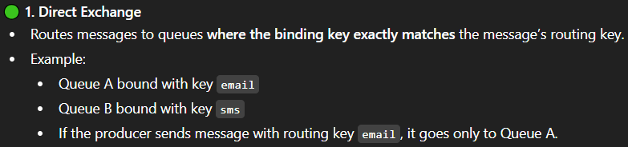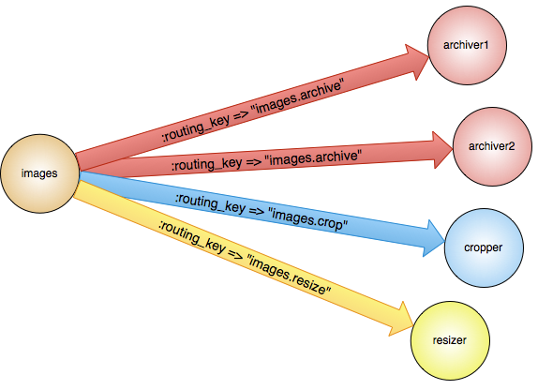

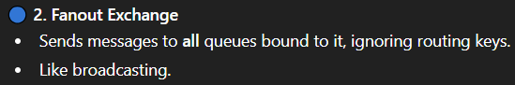 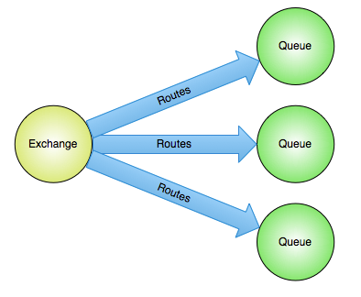

**3) Topic Echange –** route messages to one or many queues based on matching between the message routing key and the pattern that was used to bind a queue to an exchange.

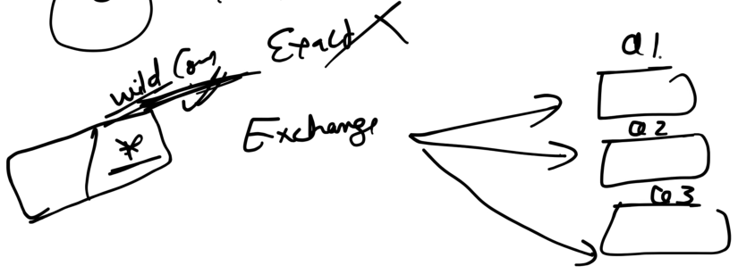

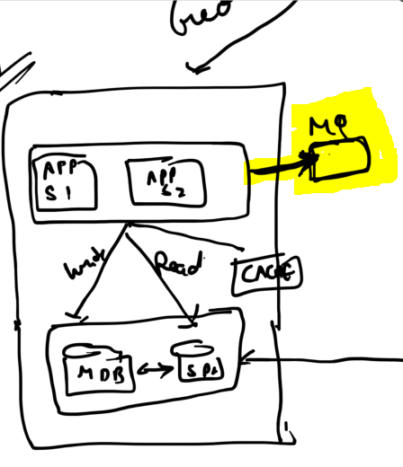 Benefits – fast processing due to async nature

**Database Scaling** – means increasing ur database’s capacity to handle more Traffic (more queries/requests) and Data (more rows/columns)

It is of 2 types – Vertical (Scale Up) & Horizontal (Sharding)

**Vertical** 🡪 increase the power of db servers like adding more CPU, RAM, SSD or faster disks.

Benefits –

* simple no change in application logic
* no data partitioning.

Drawback –

* there’s a hardware limit – you can’t upgrade infinitely
* Expensive

**Horizontal** 🡪 u can add more servers (nodes) and distribute data among them. This is also called sharding. Each **shard is stored on a separate database node.**

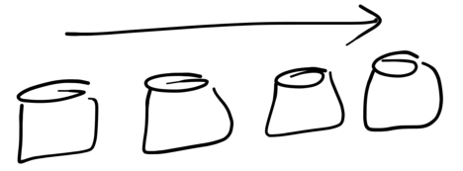 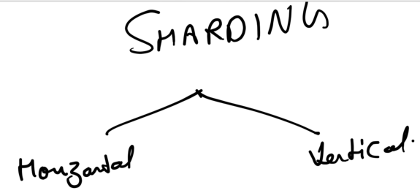

* **Horizontal Sharding (Row-wise)**

You split rows of a table across multiple shards – each shard has the same columns but different rows.

Ex- suppose Users Table has 1M rows. You might shard based on the user’s name or user_id.

Shard 1: users with names A-P

Shard 2: users with names Q-Z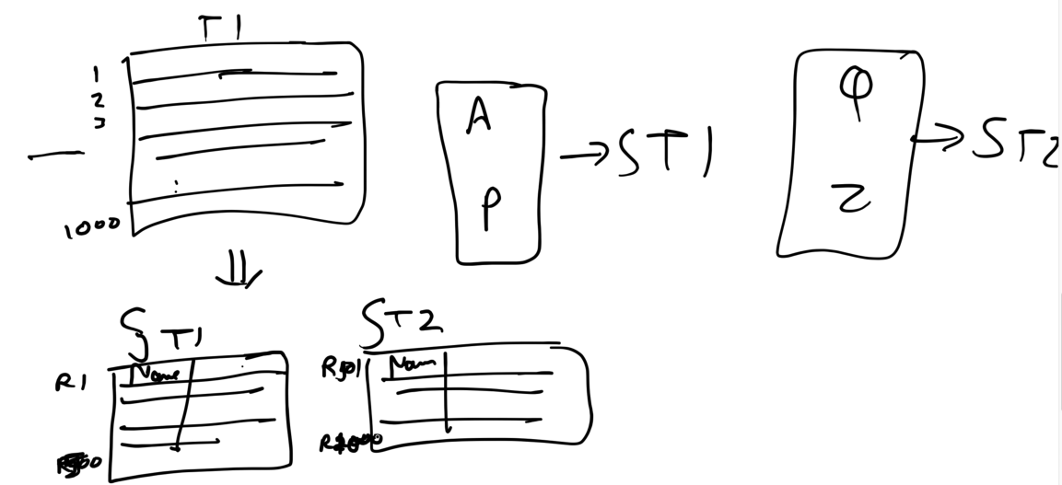

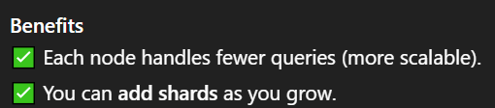(as rows grow)

* **Vertical Sharding (Column-wise)**

You split columns of a table into multiple tables — each shard has different columns, but all rows.

Ex - 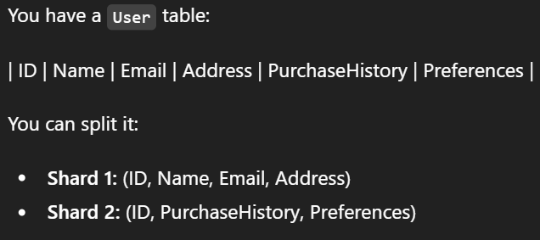

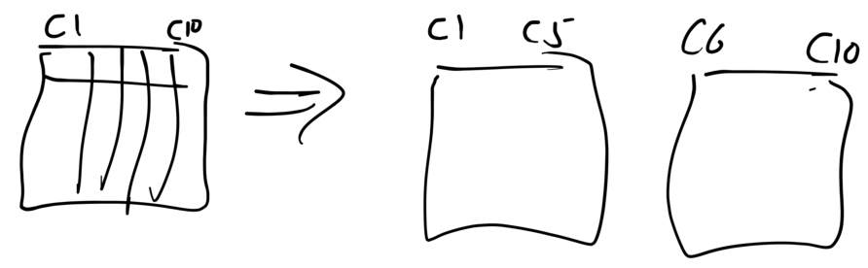

**Drawbacks –**

* **Data Imbalance:**

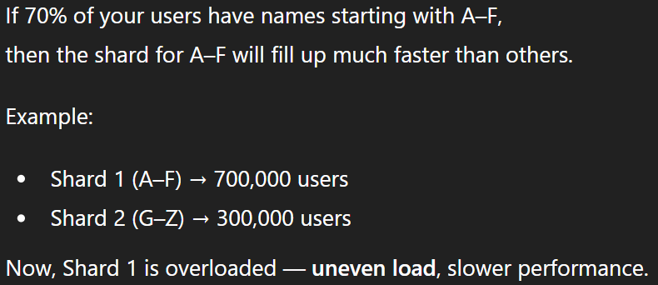

Solution: for dividing rows into shards use mod hashing on something like user_id –

For each row 🡪 hash(user_id) % total_shards

But if you add or remove shards, everything breaks. Solution: Consistent hashing

* **Cross-Shard Joins Are Difficult:**

A **join** is a SQL operation that combines rows from **two tables** based on a related column.

Ex- User table: | user_id | name |

Orders table: | order_id | user_id | product |

Now using JOIN, we can see which user bought which product.

Now if we shard both Users & Orders table using user_id, then to do Join we must look into two different shards (2 separate db nodes) making it complex and slow.

Solution: Denormalization

Normalization – In relational databases, we divide large tables into smaller, related tables and defines relationships between them using **primary** and **foreign keys**. 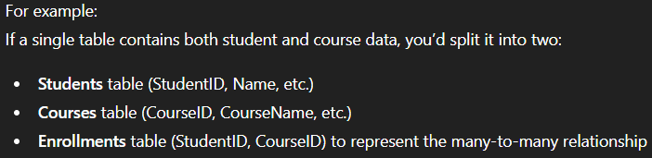

This is done to avoid duplicacy.



Denormalization means combining normalized tables or duplicate some data to reduce joins and improve query performance.

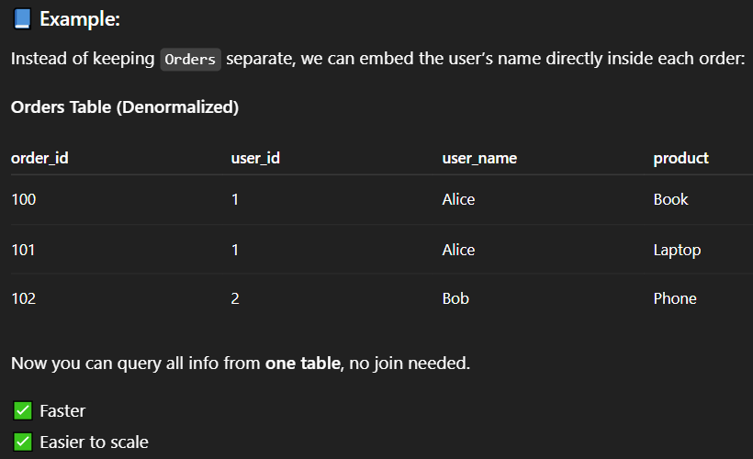

**Replication vs Sharding / Using both together**

**Replication** 🡺 **keeping multiple copies of the same data** on different nodes (servers). Ex- Imagine a DB with table of 1M users: NodeA, NodeB, NodeC all has 1M users

Benefits –

* High availability: If Node A fails, Node B or C can serve requests.
* Read scaling: Multiple replicas can serve read requests, reducing load on primary.
* Disaster recovery: Losing one node doesn’t mean losing data.

Drawbacks –

* Write bottleneck: Every write must be applied to all replicas → sync issues among replicas
* No horizontal storage scaling: All nodes must store full dataset → storage grows with number of replicas.
* Cost: More nodes storing same data → higher storage cost.

**Sharding** 🡺 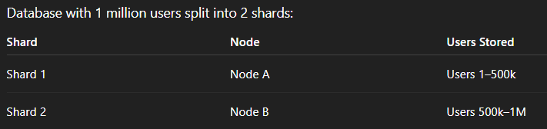

Benefits –

* Horizontal scalability: Can handle larger datasets by adding more shards.
* Write throughput: Each shard can handle writes independently → higher total write capacity.
* Efficient storage: No node stores the entire dataset.

Drawbacks –

* Partial failure risk: If Node B fails, Shard 2’s data is unavailable
* Complexity: Queries spanning multiple shards become harder
* Harder to manage than a single database

**Sharding + Replication** 🡺 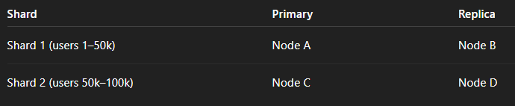

Benefits –

* If Node A fails → Node B can serve that shard.
* If data grows → Add new shards easily.
* Each node doesn’t need to store *all* data.

**Consistent Hashing**

Mod Hashing – You hash the key and then do a modulus operation with the number of available nodes. node = hash(key) % N

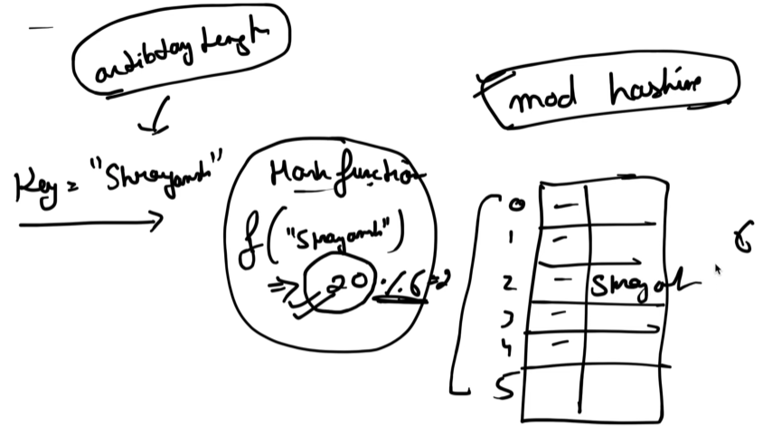

It Works fine **as long as N (number of nodes)** stays the same.  
Each key will always map to the same node. But problem occurs if this size is not fixed.

For ex-

**Load Balancing for App Server** – suppose there are 3 app server and LB is using mod hashing to equally distribute the load on app servers.

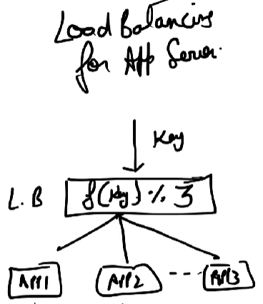 What if we add/remove servers?

**Horizontal Sharding** – you have a Users Table with millions of records. You divide it into 3 shards based on hash of the username: hash(username)%3

Let’s say your data grows, and you decide to add one more shard (Shard4).  
Now, you change your hashing rule from %3 to %4.

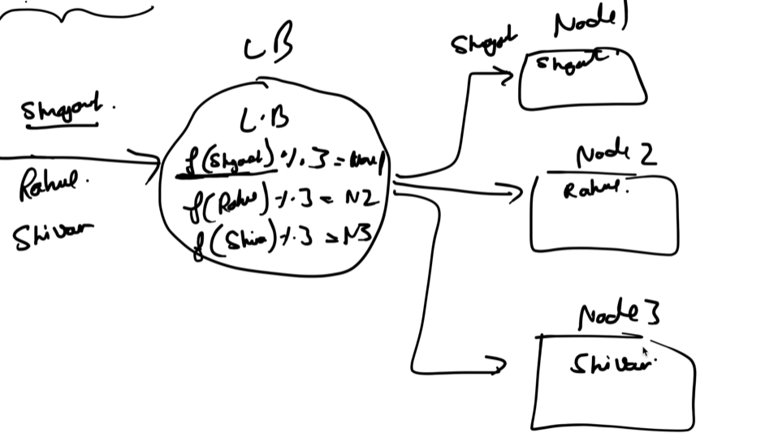

Now issue is that earlier when user “shrayansh” came, we did %3 and stored it in Node 1.

But now read request comes for “shrayansh” and after doing %4 suppose result is Node2. Now if app tries to read “shrayansh” data in Node2, data will not be present as data was stored in Node1.

So, your application will **look in the wrong place** for existing data. To fix it, you must **rebalance** (i.e., move data from old shards to new ones according to new hash values).

This process can involve **moving millions of records**, which is slow, costly, and risky.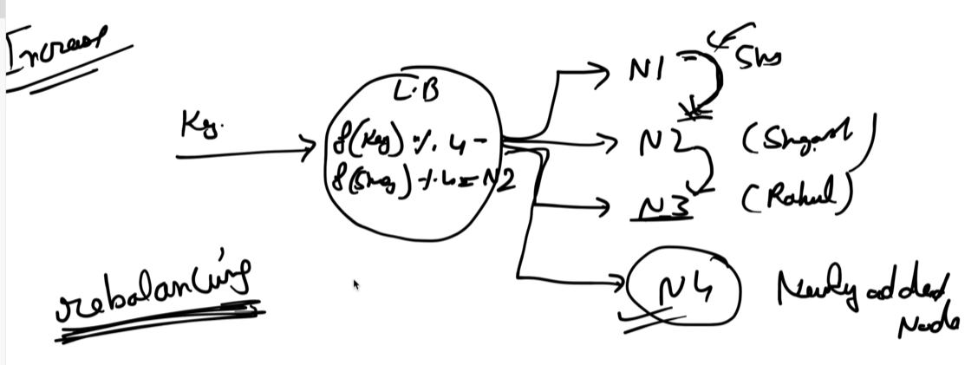

**Consistent hashing** avoids this rebalancing problem by:-

* Mapping both *keys* and *nodes* on a circular hash ring.
* When a new node is added, only the keys close to that node are moved — not all keys.
* Similarly, when a node is removed, only its own keys are redistributed.

It says that whenever any node increase/decrease then only **(1/n) of total no of key** should do rebalancing. Basically moto is to reduce rebalancing as much as possible.

**Working🡪** It uses a virtual ring. This circle represents the **output range of the hash function.** In our example we take ring of size 12. So selecting a hash function with an output range large enough to minimize the risk of collisions and ensure a uniform distribution of both data and servers.

It will try to map app/DB servers on this ring. Suppose we are doing mod hashing for server Ip address or its name. S1 🡪 hash(server1 ip) % 12 and so on for S2, S3….

Each **key** (e.g., username, file ID, etc.) is also hashed to a point on this same ring.

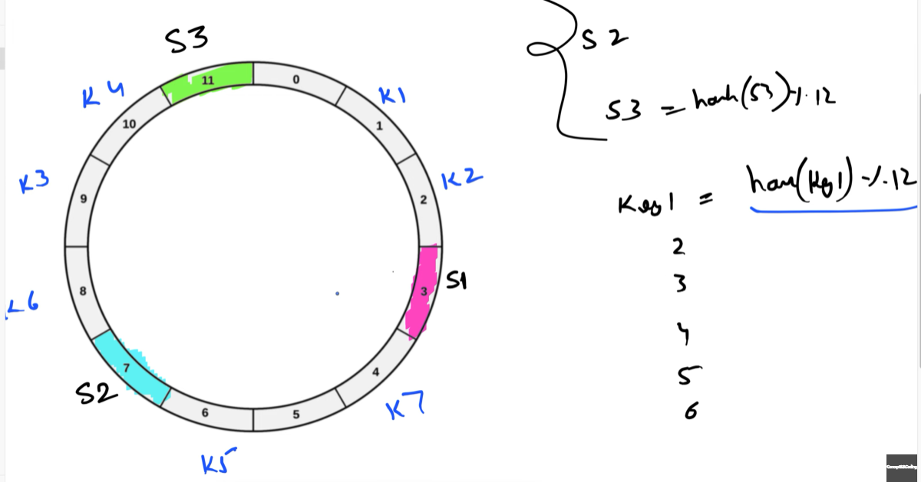 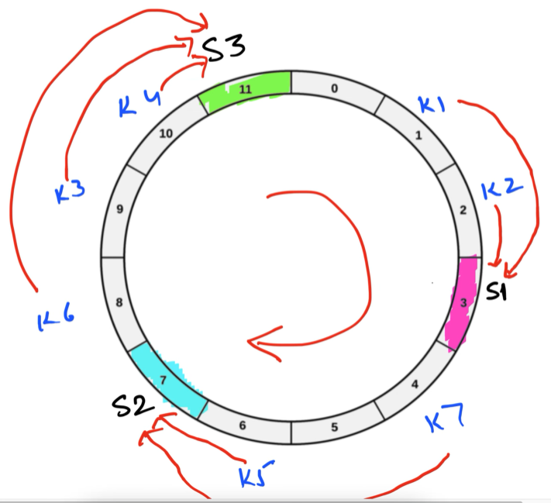

**Assign Keys to Nodes 🡪** A key is assigned to the first node clockwise from its hash position.

K1 & K2 will be handled by S1.

S2 = K7, K5

S3 = K6, K3, K4

**Now Addition of server S4 which hashes to position 5** 🡪 Only rebalancing of K7 key is need. It will now be handled by S4.

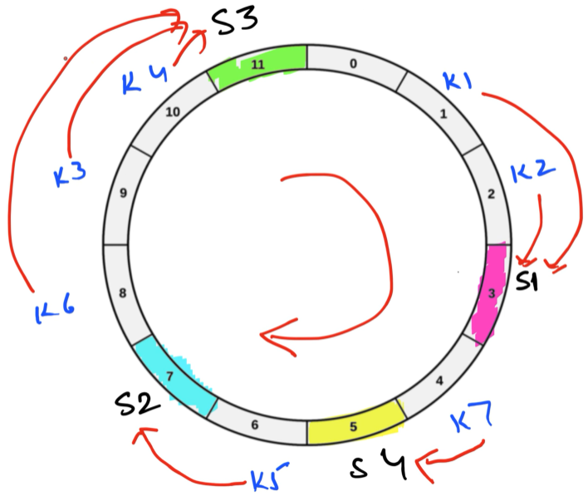

**Now Deletion of server S2 from 7** 🡪 Only rebalancing of K5 key is need. Earlier it was handled by S2 but now it will be handled by S3.

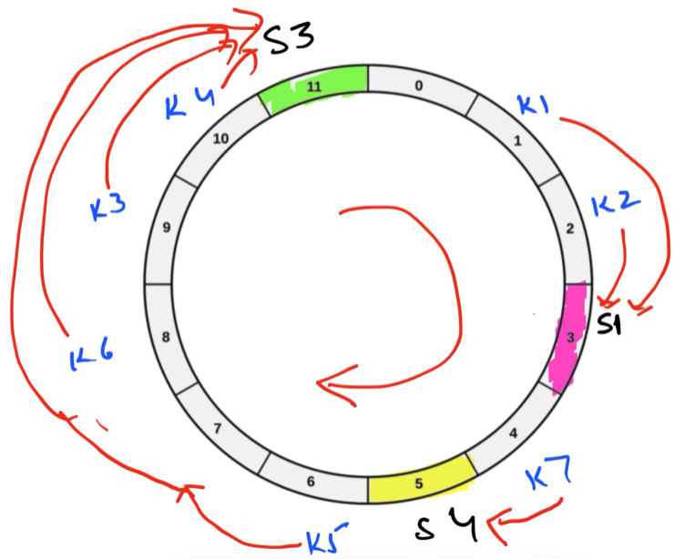

**Drawback** – we placed server on ring using mod hashing. What if server are placed consecutively? Then all load will come on single server.

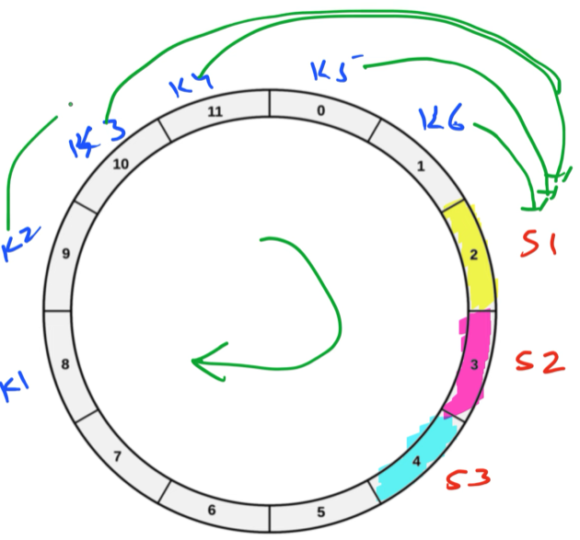

To fix uneven distribution, each **physical node** is represented by **multiple virtual nodes** on the ring 🡪 replicate server at different points. (more than 1)

Ex:- NodeA → hash("NodeA#1"), hash("NodeA#2"), hash("NodeA#3")

NodeB → hash("NodeB#1"), hash("NodeB#2"), hash("NodeB#3")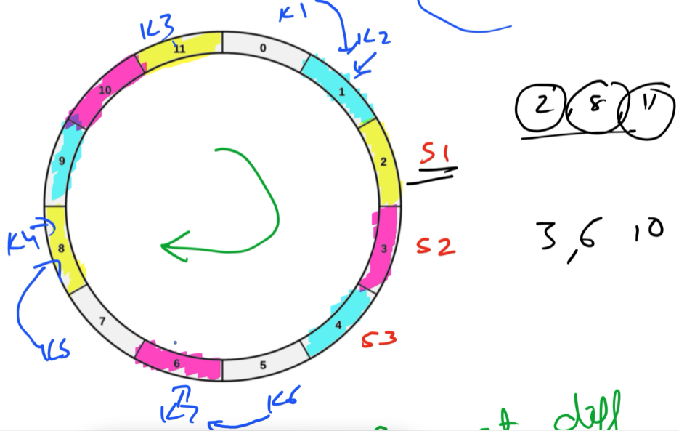 Nows keys are equally divided.

No. of replicas as such that we achieve only (1/n)% of total key when rebalancing.

Benefits –

* Minimal key movement: Only a small fraction of data moves when nodes scale up/down
* Scalable: Can handle hundreds/thousands of nodes
* Balanced load with using virtual nodes

Used in –

* **Cassandra / DynamoDB / Riak** — For partitioning data across distributed DB nodes
* **Redis Cluster / Memcached** — For distributed caching
* **Nginx / Load balancers** — To route clients consistently to backend servers

**URL Shortner**

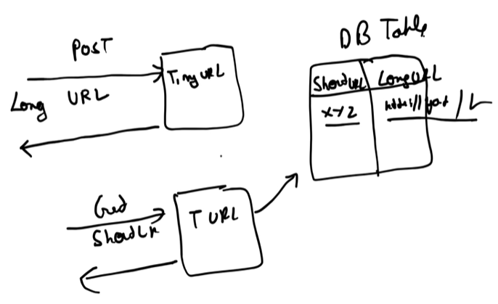

**Requirement Analysis**

* How short our URL should be ? ------ As much short as u can
* Traffic ?

10 Million URL / day 🡪 3650 M URL/ Year

Suppose I want my service to be supported for 100 years

so it should support 3650 * 100 = 365000 M urls = 365 Billion Urls.

* What all characters can we use?

Interviewer will say --- u can use 0-9 / a-z / A-Z

10 + 26 + 26 = 62 characters

Now in 62 character how many urls can we build?

If 1 length url 🡪 only 62 unique urls can be made

2 length _ _ 🡪 62^2 unique urls

_ _ _ 🡪 62^3 unique urls

So we have to reach that length such that unique urls generated by our service crosses 365 Billions as service should be supported for 100 years.

_ _ _ _ _ _ 🡪 62^6 = ~56 Billion urls

_ _ _ _ _ _ _ 🡪 62^7 = ~3.5 Trillion urls

So definitely we have to use 7 characters in our URL.

* How to generate this hashvalue ?

We have 2 ways – either use a Hash function (like MD5 or SHA-1) or Use Base 62 encoding.

**MD5** 🡪 produces 128 bits binary output. For display or storage, 128 bits output is shown as hexadecimal.

Each byte (8bits) = 2 hex characters

MD5 = 128bits = 16 bytes 🡪 16 * 2 = 32 hex characters

**Hexadecimal** (or **hex**) is a numbering system based on **16 symbols** (0, 1, 2, 3, 4, 5, 6, 7, 8, 9, A, B, C, D, E, F) We need 4 bits to store 16 values ( _ _ _ _ ) in binary format.

So if you see a hash like this: “e2fc714c4727ee9395f324cd2e7f331f”. You could rewrite each hex character as 4 binary digits.

Now we can’t choose MD5 algo as we want short url length which is of length 7.

**SHA-1** 🡪 produced 160 bits binary output.

160 bits = 20 bytes 🡪 20 * 2 = 40 hex characters so can’t use it either.

Any decimal no can be converted into any Base.

**Base62 encoding** 🡪 **representing a number in base 62**.

Steps:- Repeatedly divide that number by 62. Collect remainders in reverse order and each remainder corresponds to a Base62 symbol –

* The numbers 0–9 are represented by the digits 0–9.
* The numbers 10–35 are represented by the uppercase letters A–Z.
* The numbers 36–61 are represented by the lowercase letters a–z.

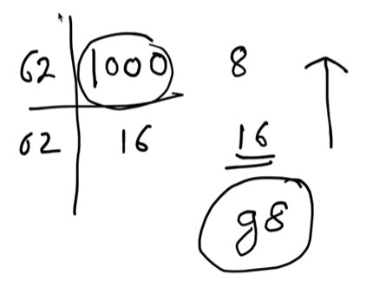 1000 will be represented as “g8” in Base 62.

We can convert our urls into base 62 encoding but we for each url we need unique id which will be converted to base 62.

Problems with base 62 –

* We need id generator
* Length could be different (like for 1000 we got only 2 length output)

**Talking about output length** –

Now lets say id generated is 16. Base62 encoding is “G” but this is not 7 length coding. So we can do padding to make it 7 characters like “G======”

Now ques is can base62 will go more than 7 character? No

In 7 character maximum value we can generate is “z z z z z z z” if u convert it decimal you will get

= ~3.5 Tillion

So we are making sure that we pick id till 100Billion so it will general url length <= 7.

**Unique ID Generation** –

**1) Auto-Increment ID form a Single Database**

Use the database’s built-in AUTO_INCREMENT column Id –

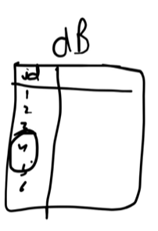(single) 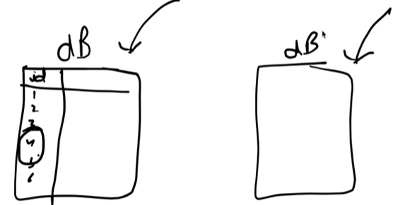(multiple db nodes)

Benefits – simple & easy to implement

Drawbacks –

* **Single point of failure:** one DB node can’t handle 10M+ writes/day reliably.
* Synchronization issue: if multiple DB servers are used, they might generate duplicate IDs (since each auto-increment starts from 1).

**2) Ticket Server** – its like centralized auto increment service. Multiple app servers will hit the ticket server to get the id.

Benefits – simplifies application logic as app servers don’t manage IDs.

Drawbacks –

* **point of failure:** if the ticket server crashes, the system halts.
* **Latency increases** as App server needs to call ticker server to get ID

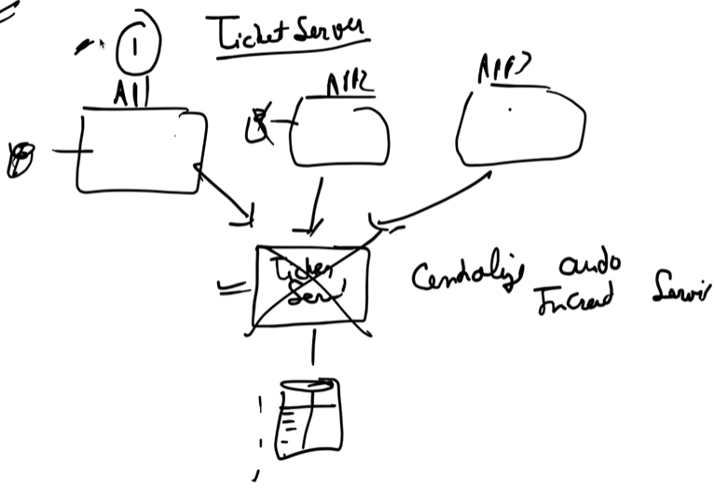

Ticker server will store the last issues ID in its database or cache so it can continue from the right no after restarts or crashes.

**3) Snowflake** – Twitter’s Snowflake algorithm generates unique 64-bit IDs in a **distributed**, **time-based**, and **ordered** manner.

It doesn’t depend on a central DB or coordination system like ZooKeeper.

Structure 🡺 1-bit | 41-bit | 10-bit | 12-bit

**1 bit** 🡪 **sign bit**, always 0 as IDs are +ve

**41 bits** 🡪 **Timestamp** in miliseconds since a cutom epoch. This ensures IDs are time-ordered. Maximum timestamp: 2^41 ms = ~69 years from custom epoch. So if ur **custom epoch = 2020-01-01**, your Snowflake ID generator can safely generate unique IDs until roughly **2089**.

After 69 years pass, existing old IDs will remain valid as they are stored in databases and referenced normally. Overflow only affects new ID generation. Solution is to set a new custom epoch in future and start generating IDs from there. We can also increase the number of timestamp bits.

**10 bits** 🡪 **machine/worker ID** – uniquely identifies the node or datacenter. Prevents collisions between different servers when timestamp is same. Max nodes: 2^10 = 1024

**12 bits** 🡪 **sequence number** – allows multiple IDs per millisecond per server. With 12 bits, each machine can generate up to 2^12 = 4096 IDs per millisecond.

**Design –** Create a separate Snowflake service, each data center has 1 or more Snowflake service nodes. App servers call the service over the network to get unique IDs.

Benefits –

* High throughput : a single machine can generate thousands of IDs per second
* Decentralized : can generate IDs on multiple nodes without a central DB.
* Time sortable IDs
* Globally unique IDs without any coordination among app servers.

Drawbacks –

* Bit Limits : 41-bit timestamp 🡪 ~69 years from custom epoch
* Each server must have a unique machine ID. Mismanagement → collisions.

4) **ZooKeeper -** Use Apache ZooKeeper as a coordination service to allocate ID ranges to different worker threads or servers.

For 7 length url we have 3.5 Trillion combinations 🡪 0 1 2 3 ……………… 3.5 Trillion.

Zookeeper divides total ID space in ranges :

* Range 1: 0 – 1M
* Range 2: 1M – 2M
* ……

Each Range is alloted to a particular server. ZooKeeper ensures no overlap with ranges assigned to other servers.

App server stores this range locally in memory. **Every incoming URL shortening request**:

* The app server uses the next ID from its **local range**.
* No ZooKeeper call is needed for each request.

When the range is exhausted: App server calls ZooKeeper again to request the next range.

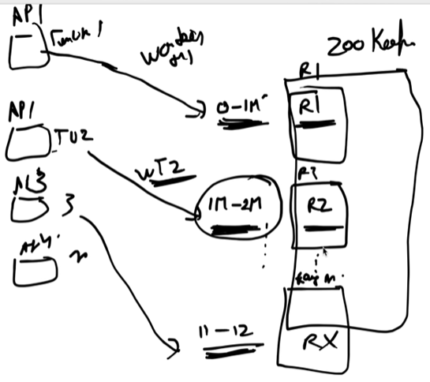

Benefits –

* Guarantees to generate a unique id in distributed environment.
* High throughput since workers generate IDs locally.
* Dynamic scaling: new worker can requests new ranges.

Drawback – Zookeeper doesn’t track how many IDs a server actually used within its range.so unused IDs in a crashed server’s range are lost. But its not a concern as we have space of 3.5 Trillion.

When the App server comes Up and request Zookeeper for range allocation, it will be allocated a new range.

We’ll use NoSQL database as it support high availability and easy horizontal scaling.

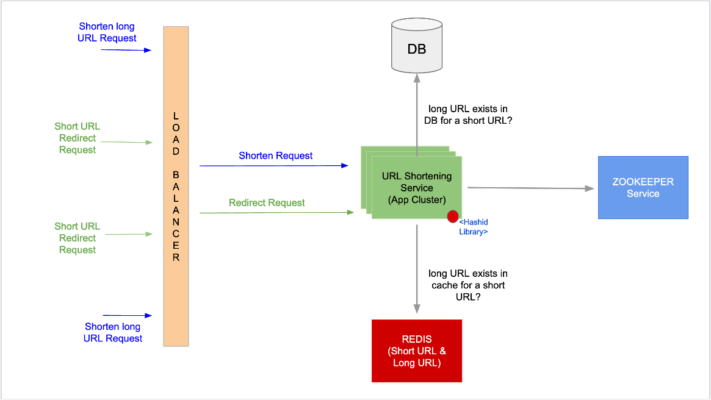

**Back of the Envelope Estimation**

It’s a rough, quick calculations about resources so that we don’t under utilize or over utilize so no wastage of resource happen. Keep assumption values simple like power of 10.

It drives our decisions for system design.

1 byte = 8 bits, 1KB = 1000 bytes, 1 MB = 1000 KB, etc.. for calculations

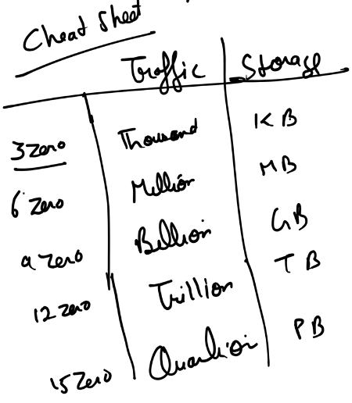 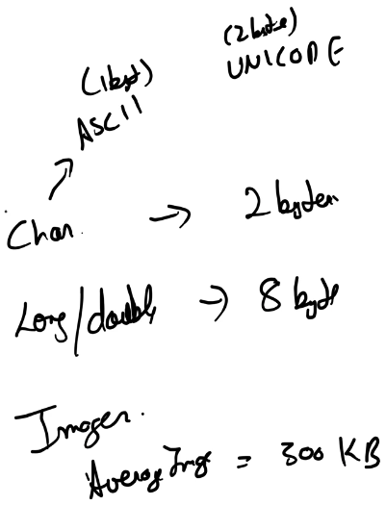

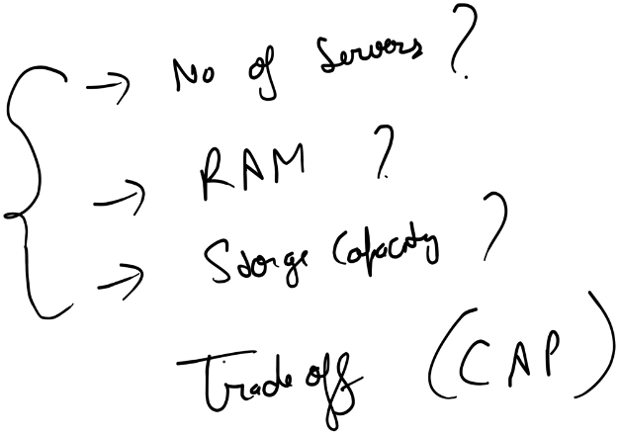

For storage calculations – use no. of zero and find whether total storage is in TB or GB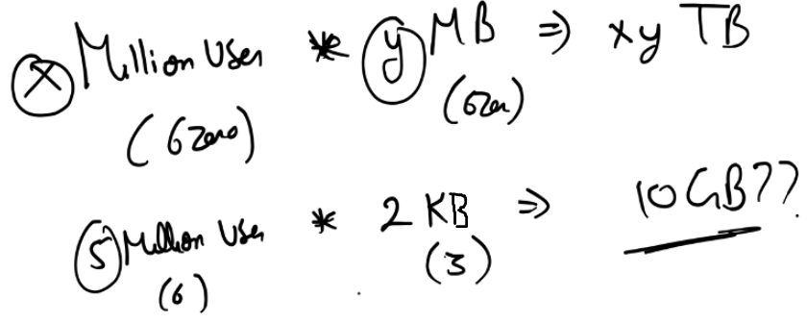

If 5 M users and each need 2 KB storage then total storage is 10GB.

**Estimation of Facebook**

**Traffic estimation –**

* Total users – 1 Billion
* Daily active users (DAU) – 25% of total users = 250 Million

In any system we have read and write operations. So assuming daily every user is doing

5 read + 2 write operation = 7 query

250 Milion * 7 query per day

In every second = (250M * 7) / (60*60*24)

= ~18K requests per second

**Storage estimation –**

* Every DAU user is doing 2 posts (each post is of 250 characters)
* 10% of users upload 1 image (300 KB)

1 post 🡪 250 characters 🡪 250 * 2 = 500 bytes

For 2 Posts 🡪 500 * 2 = 1000 bytes = 1KB

Total memory need for posts done by DAU - 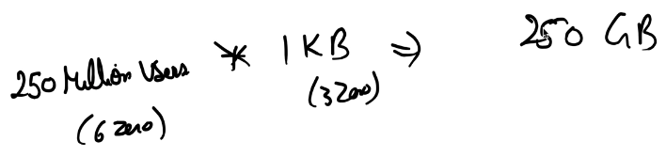 per day

Total memory need for 10% DAU uploading Image – 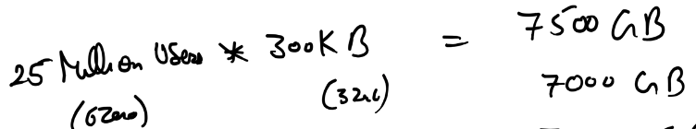 = ~8TB per day

Suppose u need to store data for 5 years – 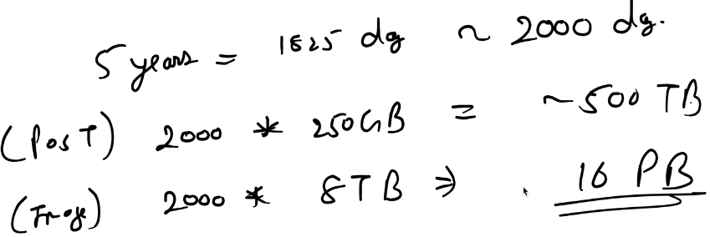

**RAM estimation** –

* For each DAU user – we are putting last 5 posts into cache (in-memory db)

1 post = 500 Bytes

5 * 500 = 2500 Bytes

Total memory space needed per day – 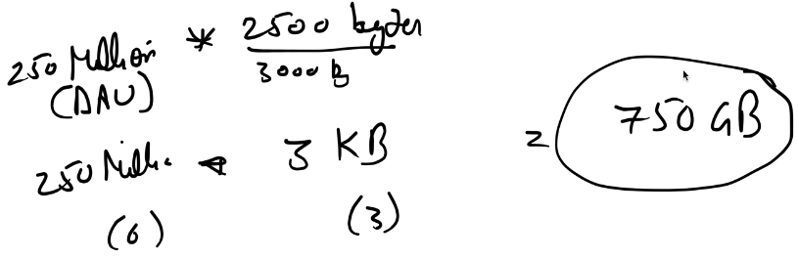

If 1 Machine can hold 75 GB of data in memory, then we’ll need 10 machines for caching(nodes)

**Latency** :- 95% of time I’ll serve a request in 500ms (serving 2 requests in 1 second)

We are getting load of 18K requests / second.

If 1 server has suppose 50 threads 🡪 it can server 100 requests / second.

To handle 18K requests / second we need 180 Servers.

**Tradeoff** :- we’ll go with availability & partition tolerance and drop the consistency.

**Design Key Value DB**

Q: Where we use it?

Ans: Amazon “add to cart” feature which uses DynamoDB where key is unique identifier for cart like userID or sessionID and value is the complete cart data.

Goals –

* Scalability
* De-centralization
* Eventual Consistency

Steps:-

1) Partition

2) Replication

3) Get & Put operation

4) Data Versioning

5) Gossip Protocol

6) Merkle Tree

**Partition**

**Goal** :

* Distribute data evenly across multiple servers to achieve **scalability** and **load balancing**.
* Handle **millions of keys** across geographically distributed data centers.

**Hash Table Limitation:**

* A simple in-memory hash table works for a single-node key-value store.
* But a single node cannot scale for millions of users or high traffic; it becomes a bottleneck.

**Partitioning via Consistent Hashing:**

* **Consistent hashing** maps both **keys** and **servers** to a **hash ring**.
* Each server is responsible for the keys that fall in the range between itself and its predecessor on the ring.

Ex: K1="car" hashes to 45. Server S1 is responsible for hash range [1-50] including 45.

K1 = "car" → stored in S1.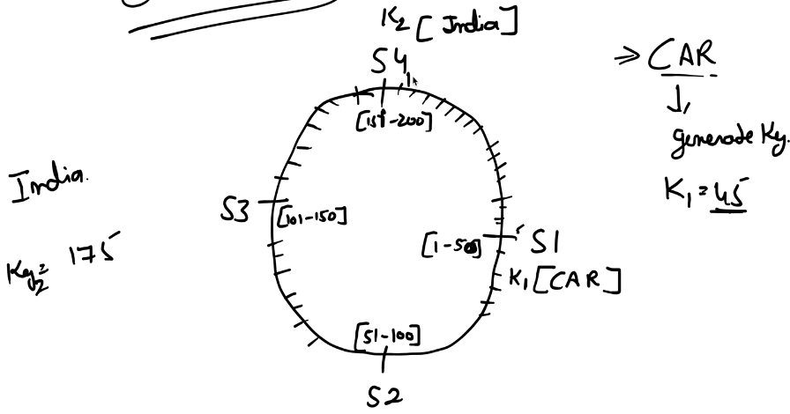

Problem in CH:

* what if there are certain keys which always fall in range of S1 server, causing uneven load
* S1 gets too many requests; other servers are underutilized.

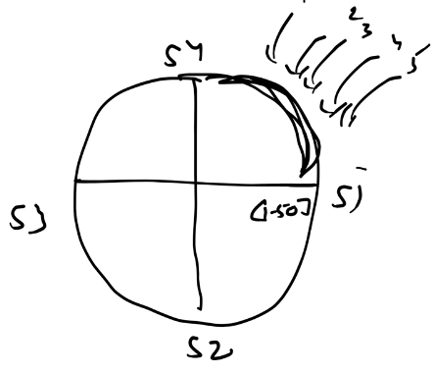 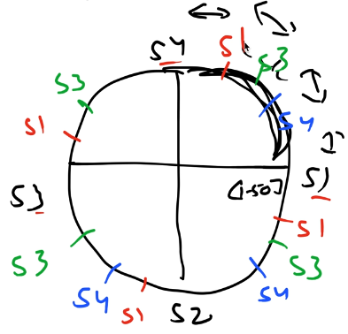

Solution: Virtual Nodes

* Each physical server is represented by multiple **virtual nodes** on the hash ring.
* Keys are mapped to the nearest virtual node.

**De-centralization** – It means if any failure happen in one particular node, then our system should not get down. No single point of failure.

**⚠️ Problem in Partitioning with Consistent Hashing**

While **consistent hashing** effectively distributes data across multiple servers, it alone does **not guarantee availability**.

Let’s consider an example:

* The key K1 = "car" hashes to 45.
* Based on the ring structure, this hash value belongs to **Server S1**.
* Therefore, S1 stores the record for key ”car”

Now, suppose **S1 fails** (due to hardware crash, network partition, or maintenance).

When a client sends GET(K1):

* The system looks up the ring and determines that S1 is responsible.
* But since S1 is unavailable, the data cannot be retrieved.
* The request fails → **loss of availability**.

**Replication**

**Goal** :

* To make the system **fault-tolerant and highly available**, we must ensure that **multiple copies** of each key exist across different nodes.
* Even if one node fails, data can still be served from replicas.

**Key Terms:**

* **N 🡪 *Replication factor***: The total number of nodes that store copies of a key.
* By default it is 3 but it’s configurable.
* **Coordinator** – It is the first node in clockwise direction whose hash position is >= key hash.
* It first receives client’s request for a specific key.
* You move **clockwise** on the ring from the coordinator’s position and pick the next **N−1 unique nodes** to serve as replicas.
* **Preference List** - Each key range has an **ordered list of nodes** responsible for storing it.
* The **first node** is always the coordinator.
* This list is used by both PUT and GET operations to know which nodes to contact.
* When a request arrives, the node computes the preference list for that key using hash ring structure which is cached locally in each node.

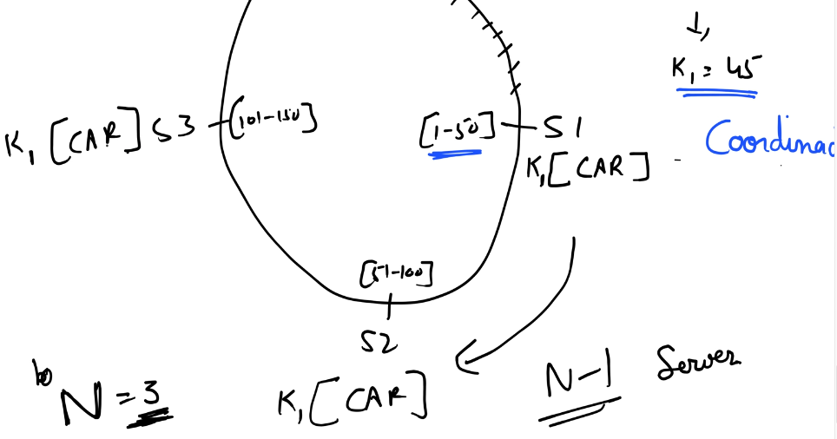 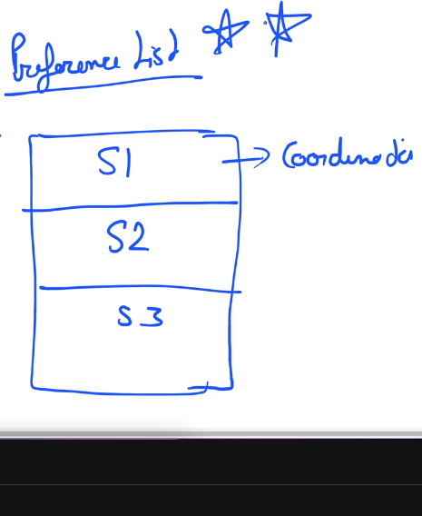 When the coordinator node picks replicas, it follows two key rules: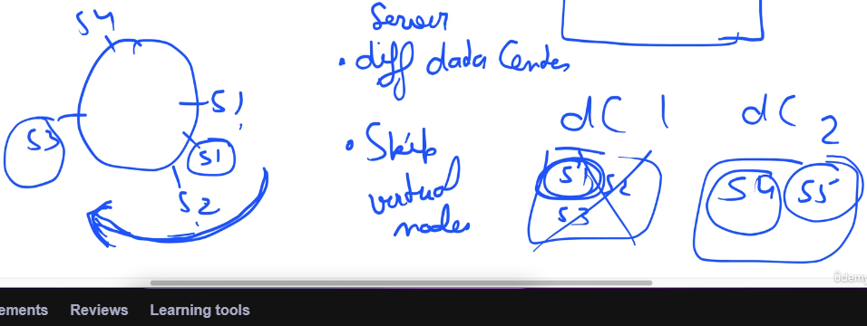

**PUT Operation**

**Goal:** Store a new key–value pair (e.g., ("CAR", "Tesla")) and replicate it to ensure high availability.

**Step-by-step Flow:**

**1)** **Client Request**: PUT (“CAR”, “Tesla”)

**2) Key Hashing and Coordinator Selection**

* Suppose hash("CAR") = 45.
* On your ring, key 45 falls in the range [1–50], handled by S1.
* So S1 becomes the coordinator for this key.

**3)** **Preference List Lookup**

* Each node knows the full ring topology and can compute the **preference list** for any key range.
* With replication factor **N = 3**, the preference list for key 45 is: [S1, S2, S3]

4) **Storing the Data and Replication to Other Nodes**

* S1 stores the key–value pair locally:  
  K1["CAR"] = "Tesla"
* Then, it sends asynchronous write requests to S2 and S3 to replicate the data.

**5)** **Write Quorum (W)**

* W defines how many replicas must acknowledge successful write before responding success to the client.
* Ex- N = 3, W = 2  
  → S1 waits for successful writes from any 2 replicas (including itself).
* Once W nodes have acknowledged (say S1 + S2), the PUT is considered successful.

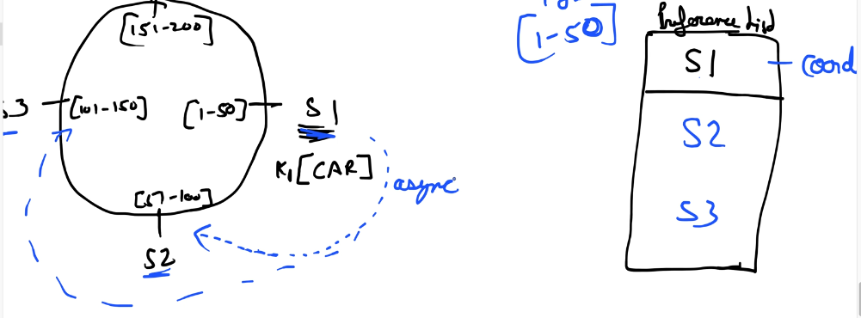

**GET Request**

**Step-by-step Flow:**

**1) Client Request:** GET(“CAR”)

**2) Request Routing via Load Balancer:** A **Load Balancer (LB)** sits in front of the servers. Types –

* **Generic LB**: Sends requests to any server in the ring without considering data placement.

Ex- If the key CAR (hash 45) is managed by S1, but the LB routes the GET request to S4,

S4 will: Look up the preference list to find the coordinator for key 45 (S1).

Forward (hop) the request to S1.

If S1 is down, it will try the next replica (S2).

Drawback: simpler implementation but higher latency due to extra network hop.

* **Partition-Aware LB:** Routes the request **directly** to the coordinator (S1). Low latency

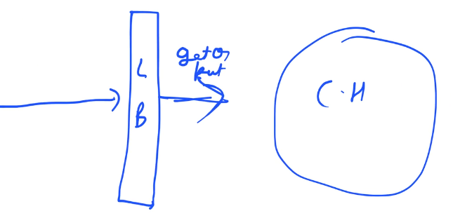

3) Coordinator Retrieves the Data

* Once S1 receives the GET request, it identifies the **preference list for key 45** as [S1, S2, S3].
* It sends parallel read requests to all replicas for the latest copy of the key.

4) **Read Quorum (R)**

* The coordinator waits until it has received responses from at least **R replicas**.
* Ex: N = 3, R = 2  
  → Wait for any 2 responses (say S1 and S2).

**(R + W > N) Rule :**

* Guarantees that reads and writes overlap on at least one common replica, ensuring **strong consistency**.
* Overlap guarantees that any read operation will access at least one node that has the most up-to-date value.
* Ex: For N = 3, W = 2, R = 2, since 2 + 2 > 3, there is guaranteed overlap.

**Data Versioning**

Distributed systems like DynamoDB replicate each key’s data across multiple nodes for **high availability** and **fault tolerance**.

However, when a node is temporarily **down**, or **network partitions** prevent replicas from synchronizing, each replicas get have different version of the same key.

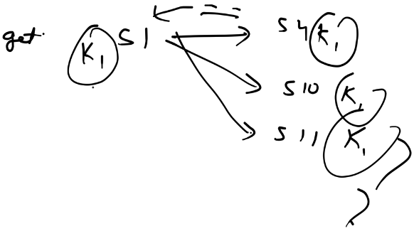 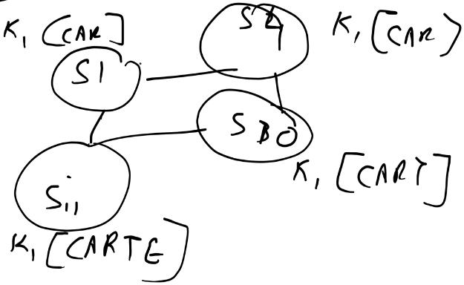

Hence, the system must be able to:

* Detect that **multiple versions** of the same object exist.
* Decide whether one version **supersedes** another or both must be **preserved**

This is achieved through **data versioning** using **vector clocks.**

**Vector clocks :**

* It is a list of {server, counter} for each key.
* Each Node Maintains Its Own Vector Clock Per Key
* When a node performs a write, it: Increments its own counter in the vector clock and preserves the counters of other nodes.

**Step-by-step Flow:**

**1)** **Initial write:** PUT(K1, "CAR")

* S1 (coordinator) handles the request. It creates a **vector clock**: {S1:1}.
* S1 stores → (K1,"CAR", {S1:1}) and replicates this to S2 and S3.
* Now all replicas have: CAR {S1:1}

**2) Second Write While S1 is UP:** PUT(K1, "CART")

* S1 processes it and increments its counter in the vector clock → {S1:2}.
* Old value CAR {S1:1} is replaced with new one CART {S1:2}.
* S1 asynchronously propagates this update to S2, S3.

**3) Node Failure and Network Partition:** S1 is down

* A new write arrives at S2: PUT(K1, "CARM")
* S2 has last seen {S1:2}, so it increments its counter: {S1:2, S2:1}
* It tries to replicate to others but network partition prevents contact with S3.
* Simultaneously, S3 receives another write: PUT(K1, "CARR")
* S3 has last seen {S1:2}, so it increments its counter: {S1:2, S3:1}

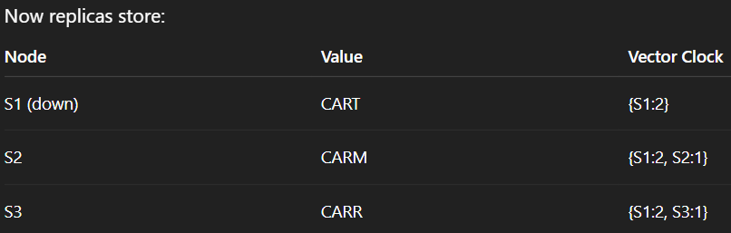

**4) Read After Recovery**

* Now S1 comes back up and receives: GET(K1)

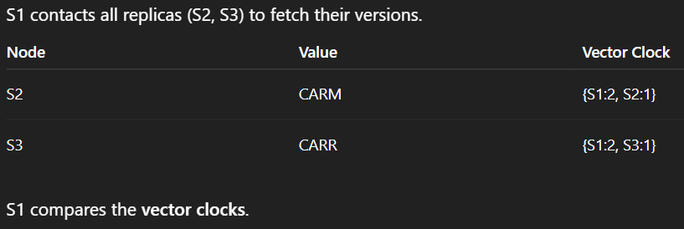

* {S1:2, S2:1} and {S1:2, S3:1} are **concurrent** because neither dominates the other.

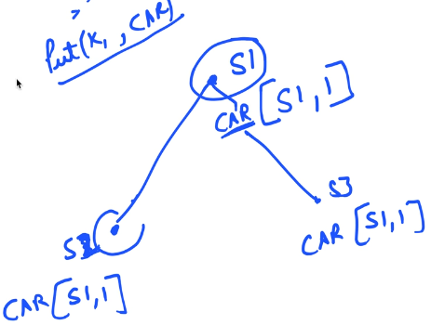 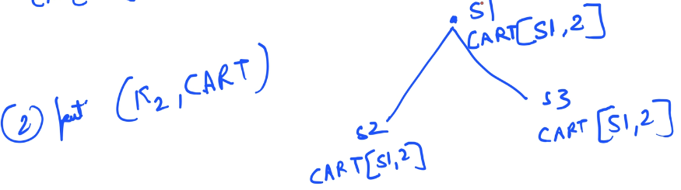

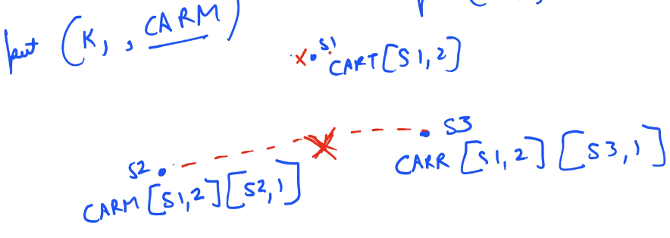

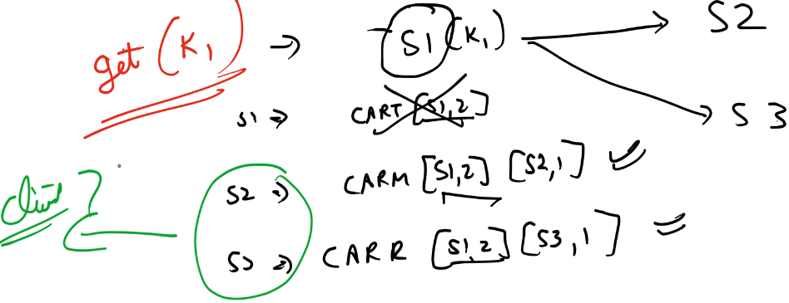

**5) Conflict Handling (Reconciliation)**

* Since S1 cannot determine which version is newer, it returns both versions to the client.
* The client (e.g., AddCartService) applies custom conflict resolution logic like **Last-write-wins** (based on timestamps)
* Client sends back a resolved PUT(K1, “CARRM) to S1
* S1 takes the vector clocks from both conflicting versions it saw: {S1:2, S2:1} and {S1:2, S3:1} and it merged them by taking the max of each counter per node : {S1:2, S2:1, S3:1}
* S1 is now performing a new write, it increments **its own counter**:{S1:3, S2:1, S3:1}

**6) Replication to S2 and S3:** S1 sends the update asynchronously to S2 and S3

* When **S2** receives it, it compares {S1:3, S2:1, S3:1} with its local {S1:2, S2:1}
* S1’s version dominates so S2 updates it value to "CARRM" [{S1:3, S2:1, S3:1}]
* Similarly for S3: local {S1:2, S3:1} is replaced by {S1:3, S2:1, S3:1}

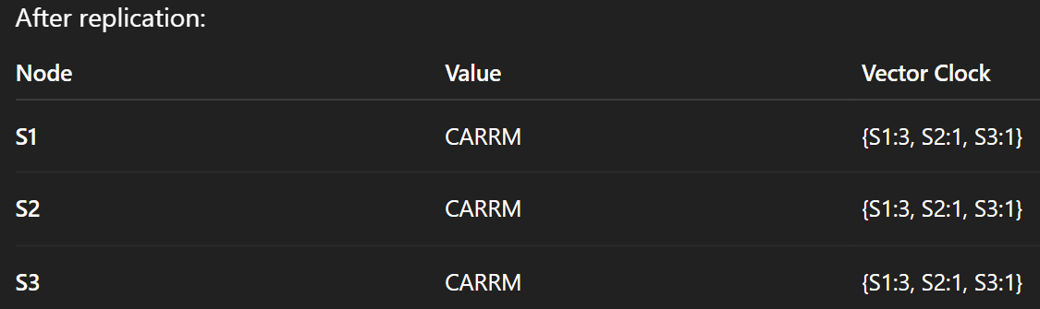

**7) Future Updates**: suppose S1 goes down again, the next PUT(K1, “CARRT”) comes to S2

* S2 looks at its current vector clock {S1:3, S2:1, S3:1} and increments its own counter.

New vector clock = {S1:3, S2:2, S3:1}

* S2 stores "CARRT" locally, and when S1 comes back, replication ensures it receives this version. S3 will also get this version.

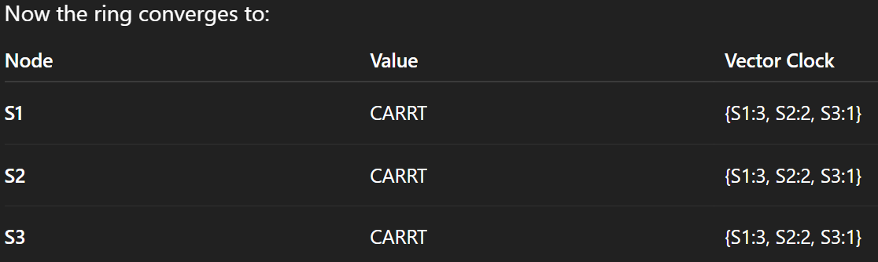

🡺 This is how we achieve **Eventual Consistency** – For a GET request you might get stale data but over the time after reconciliation and all, if you again make GET request you will get latest data. All replicas will eventually converge to the same state after failures heal.

🡺 DynamoDB maintains **Availability** & **Partition Tolerance** and sacrifies **Consistency**. It is not guaranteed that u’ll always get latest data.

**Gossip Protocol**

It is a decentralized peer-to-peer communication method for distributed systems like DynamoDB, Cassandra to:

* Keep every node informed about cluster membership.
* Detect node failures or new nodes joining.
* Propagate information in a **scalable, decentralized, and fault-tolerant** way.

Instead of a central coordinator maintaining cluster state, all nodes exchange small pieces of state with each other periodically — similar to how **rumors spread in a crowd**.

**Key Components**

1) Membership List – Each node maintains a table of all nodes in the cluster with their status, heartbeat counter, additional metadata (like range responsibility, etc)

2) Heartbeats - Every node periodically increments its **own heartbeat counter**. It acts as a logical timestamp that shows liveness.

3) Gossip Messages - At regular intervals, each node **randomly selects some nodes** and shares: Its own membership info and the information it has accumulated about all servers.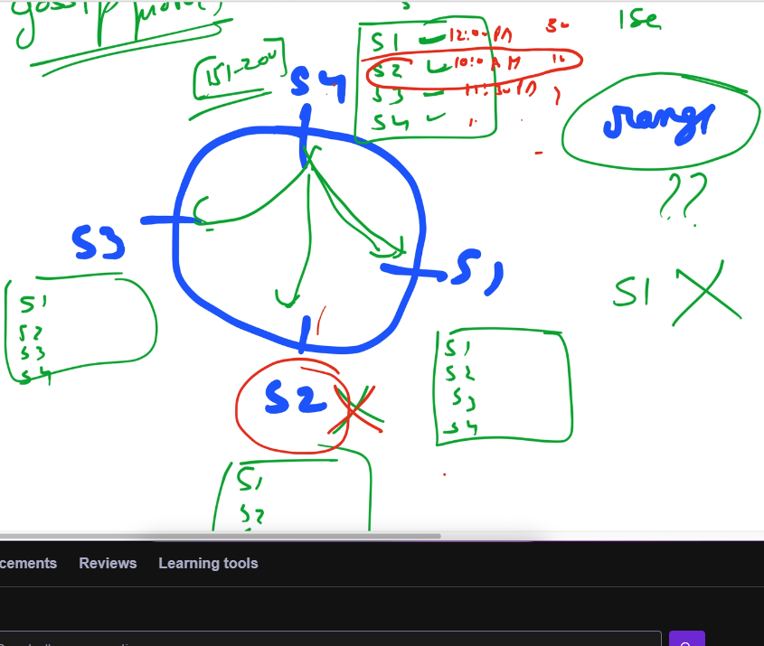

Suppose S2 fails :

* It will stop incrementing its heartbeat.
* S1, S3 and S4 preiodically gossip with each other.
* After a few gossip rounds, they all notice that S2’s heartbeat counter **hasn’t increased** for multiple intervals.
* Each node independently suspects: “S2 might be down”
* Once **more than one node** confirms this, S2 is marked as **“dead”** and removed from the membership list.

**Merkle Tree**

In a replicated key-value store (like Dynamo, Cassandra), different replicas may drift apart over time due to: node failures, network partitions, or async replication delays.

**We need a way to detect inconsistencies efficiently between replicas.**

**Merkle Tree** is a **binary tree of hashes** used to efficiently compare large datasets (like key-value data across replicas) without checking each data.

* **Leaf node** represents the hash of a key-value pair (or a small segment of data).
* **Internal node** represents the hash of its two child nodes.
* The **root hash** summarizes the entire dataset.

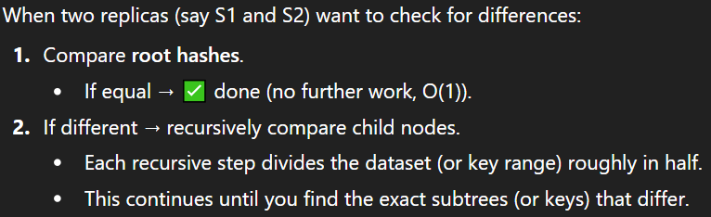

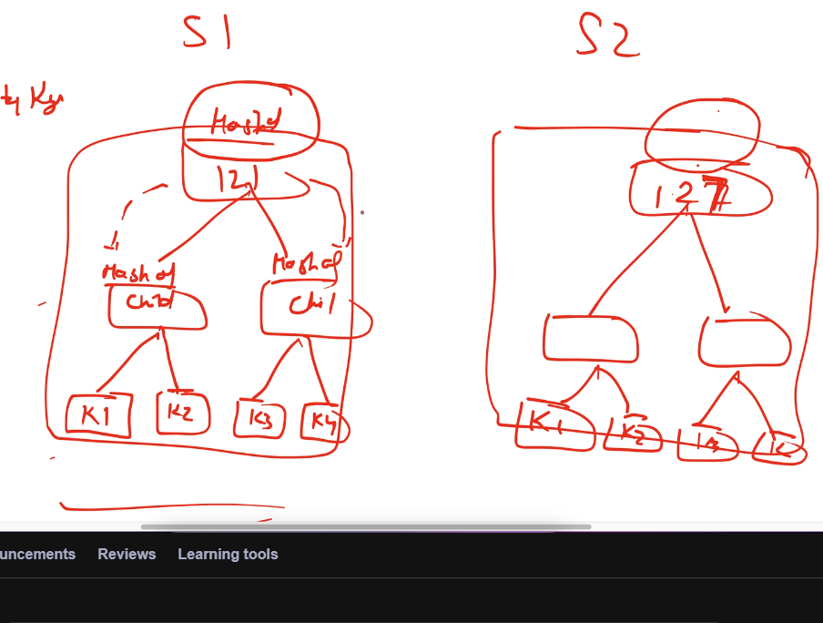

Advantage – We simplified the complexity by dividing search in half.

**SQL or NoSQL?**

**SQL** – it’s a structured query language used to manage data in RDBMS such as MySQL, PostgreSQL

**Structure 🡪** Data is stored in a **structured, tabular format** — rows and columns within tables. Using Primary Keys and Foreign Keys we define relationships between tables.

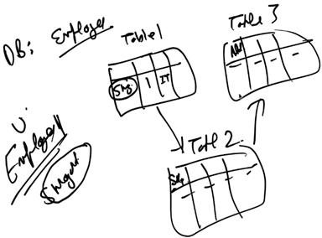  
**Schema-first** approach: The database schema (tables, columns, datatypes, relationships) must be defined before inserting data.

**Nature** 🡪 In most deployments, an SQL database is **centralized** — all related tables for a particular dataset reside on the **same server**.  
Ex- *EmployeeDB* database stores all employee-related tables (Employee, Salary, Department) and all data for a given employee resides within the same server (unless explicitly sharded).

If these tables were stored across **different servers**, then every JOIN query would require **cross-server communication** making it slow, complex, and inconsistent (as different servers could have different data states)

This schema enforcement make SQL databases less distributed.

**Scalability** 🡪

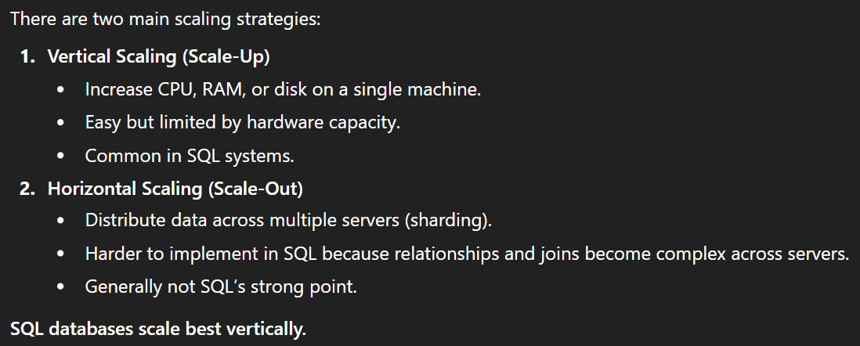

**Property** 🡪 RDBMSs maintain **ACID** properties for data reliability:

* **A**tomicity: A transaction is all or nothing.
* **C**onsistency: The database always transitions from one valid state to another.
* **I**solation: Transactions are independent.
* **D**urability: Once committed, data persists even after crashes.

**NoSQL (Not only SQL)**

**Structure 🡪** designed for unstructured or semi-structured data that doesn’t fit neatly into tables or where schema flexibility, massive scalability, and performance are prioritized over strict consistency.

**Types of NoSQL Databases –**

**1) Key-value DB**

* Simplest NoSQL model.
* Data stored as key–value pairs (like a hash map).
* The **value is opaque** — the DB doesn’t understand its internal structure.
* **Querying:** Only possible by key.
* **Example:** AWS DynamoDB, Redis.

Use when: You need ultra-fast lookups.

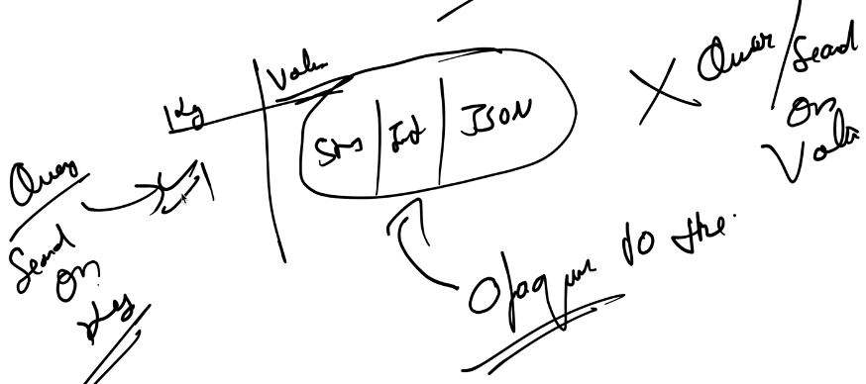

**2) Document DB**

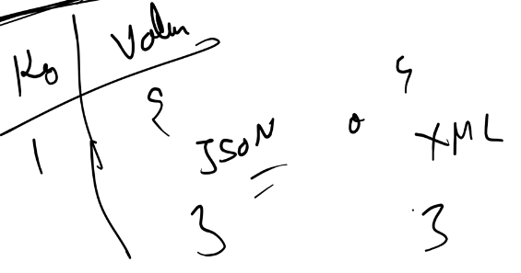

Its different from Key-Value DB as here you can search on basis of key and query on value as well. Ex- MongoDB

**3) Column wise DB**

* Each key maps to a set of column-value pairs. Ex- Cassandra
* The number of columns can be dynamic. Some key can have more no of columns and some can have low.

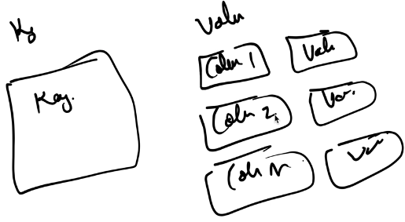 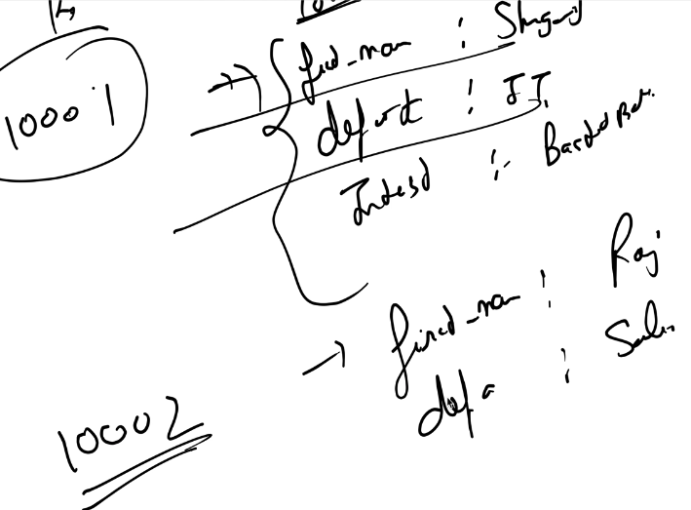

**4) Graph DB**

* Data is stored in node and edge (which shows relationship) Ex- Neo4j
* Perfect for networks — e.g., social media, recommendation engines.

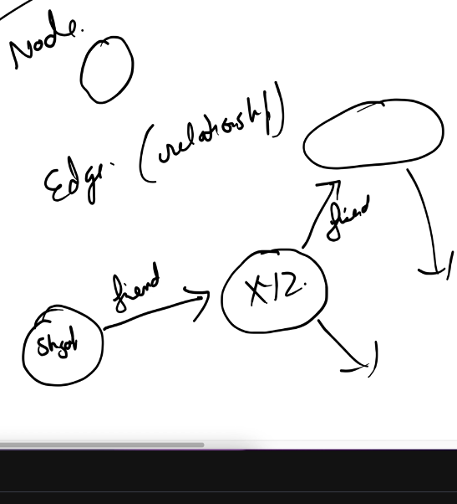

**Comparison with SQL:**

* SQL also models relationships (via joins), but queries require scanning multiple tables and all rows. Ex- find all “friends of friends” of a user form User & Friendship table.
* Graph DBs maintain *direct links* → faster traversal of connected data.

**Nature** 🡪 NoSQL databases are **distributed by design** — data is stored across multiple nodes.  
For ex- If there are 10 million users, Node1 may store 2M users, Node2 another 2M, etc.  
Replication ensures **high availability** and **fault tolerance**.

**Scale** 🡪 **Horizontal Scaling (Scale-Out)**  
Add more nodes - distribute or replicate data as traffic grows.

**Property** 🡪 It does not follow ACID. It follows BASE property.

1. **BA – Basically Available** :- The system guarantees that it will *always* respond to requests — even if some nodes or parts of the system are down.

You’ll always get a response, but **it might not be the most up-to-date data**.

Ex- If Node A is down, Node B (replica) still responds to your query — ensuring the app doesn’t crash or hang.

1. **S – Soft State** :- The state of the system may change over time, even without interaction.

That’s because replicas in a distributed system keep synchronizing with each other in the background.

During this sync, data on different nodes may update automatically.

1. **E – Eventual Consistency** :- After a write operation, some nodes may have the new data while others have old data but eventually over time, as the system syncs all nodes will reach the same state.

**When to use which one?**

|  |  |
| --- | --- |
| **SQL** | **NoSQL** |
| Flexible query functionality like 3 tables join or 5 tables join. | It does not support complex queries.  You know in advance what column u need for search capability. |
| Used when data has relational nature (tightly dependent to each other like parent, child relationship) | We put data which is not tightly dependent to each other. Ex- key-value pair. |
| Use when Data Integrity (ACID) is required. When u cannot loose a single transaction.  Ex- In financial institution SQL is must | No ACID,  Used to store large, distributed data where loosing 1 or 2 transactions is of no impact. |
| High consistency over High availability | High availability,  High performance (in search , query)  Where u can afford to loose some consistency. |
| Vertically scale | Horizontally scale |

**HLD of Chat Application** (WhatsApp, Discord, Telegram, Slack, FB Messenger)

**Requirement Gathering**

1. **Functional**

* 1-1 send/receive message (text)
* Group message support
* Last seen/ online/ offline
* User login/ authentication

1. **Non-functional**

* Scalability 🡪 handle huge traffic
* Low latency in send/receive message
* Availability

**Back of the Envelope Estimation**

* Total users -> 2 Billion
* DAU -> 50 Million
* 1 user can send -> 10 messages to 4 people in a day

How many message per day = 50 Million * 40 Msg = 2000 Million = 2 Billion Msg/day

Assuming 1msg = 100 characters = 100 Bytes

Memory required = 2 Billion * 100 Bytes = 200 GB/day

If I want to maintain chat history for 10 years = 200 * 10 * 265 GB memory needed.

**Different Approaches**

**1) Direct Peer-to-Peer (P2P) Communication**

* If two devices know each other’s IP, they can communicate directly.
* Pros: no central server required, reduced latency.
* Cons:

**Not scalable** – each peer must maintain multiple connections.

**Security risk** – exposes user IP addresses.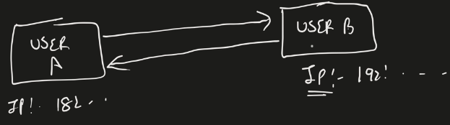

**Conclusion** : P2P is unsuitable for a large scale chat system.

**2)** **Client server architecture**

* A **central chat server** manages message delivery between clients.
* Clients connect to the server, and the server relays messages to recipients.

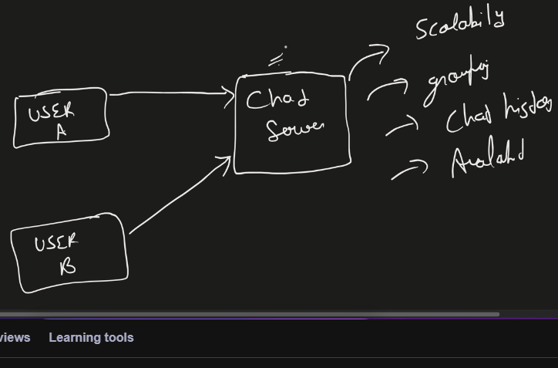

**Communication Protocols**

**1) HTTP**

* Works on the request-response model : Client initiates request → Server sends response.
* Problem : for userB to receive message, Server cannot initiate communication.

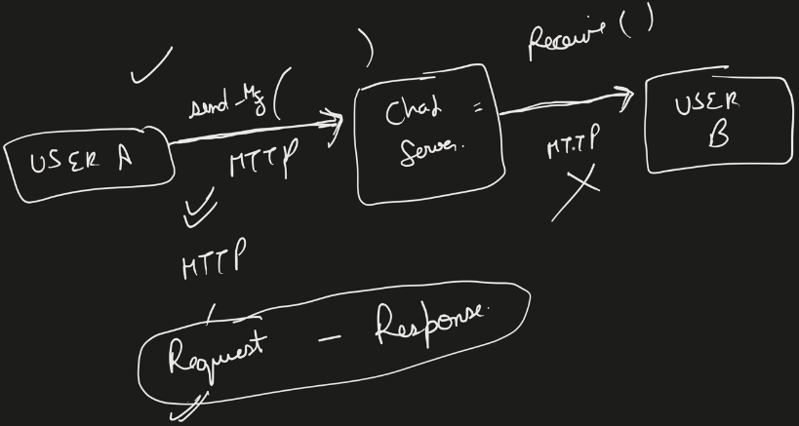

Different ways to do this – we can enhance HTTP using **Polling** or **Long Polling**.

**2)** **Polling**

* The client repeatedly sends HTTP GET requests asking: *“Do you have a new message for me?”*
* If yes → Server sends message.  
  If no → Connection closes, and client repeats the process after some interval.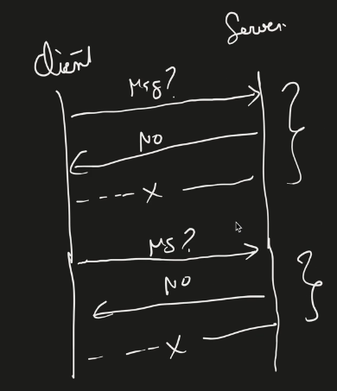

Drawbacks:

* Very inefficient — most requests get “No new message.”
* High **network overhead** and **server load**.
* Not scalable for millions of users.

3) **Long Polling**

* Client opens a HTTP connection and waits after sending GET request for messages.
* Server holds the request until a message arrives or a timeout occurs (e.g., 30–60s).
* After receiving a message or timeout, the client **reconnects**.

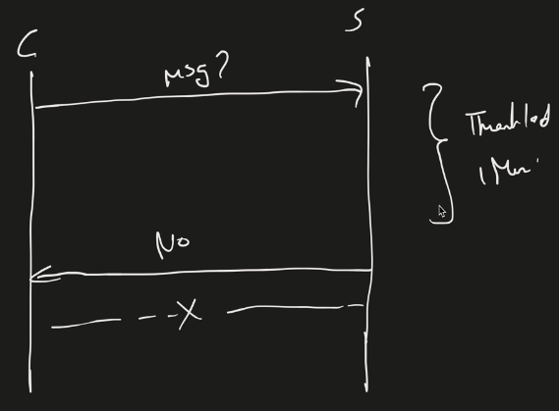

* Reduces no of requests on server compared to polling. But still not for realtime large scale chat application.

**4) WebSocket**

* It is **persistent**, **bidirectional** communication over a single TCP connection.
* Both client and server can send multiple messages to each other.
* Uses **HTTP handshake** to establish the connection, then upgrades to the WebSocket protocol.

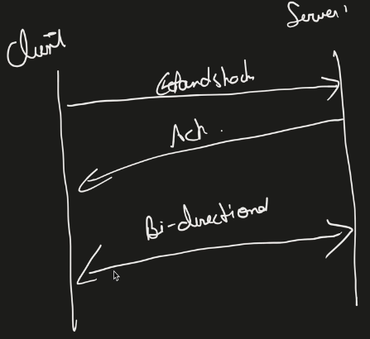 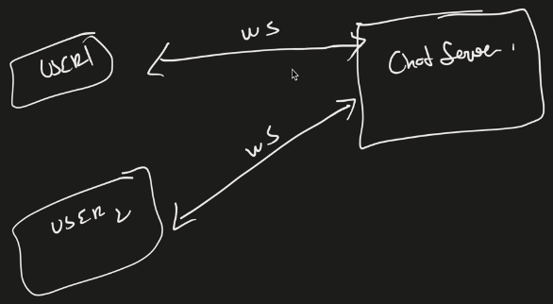

* **Persistent** - connection is open throughout session, this reduces connection setup overhead.

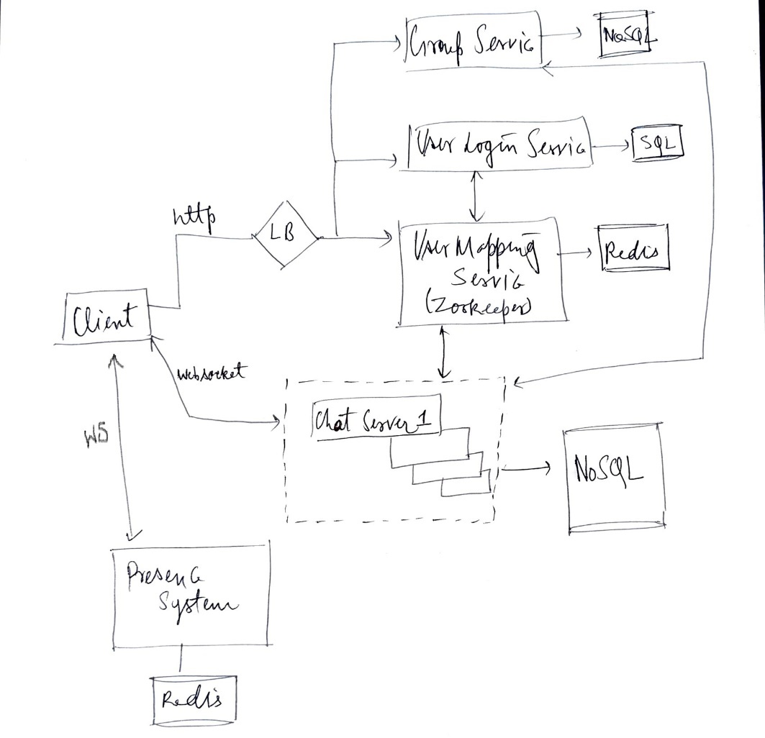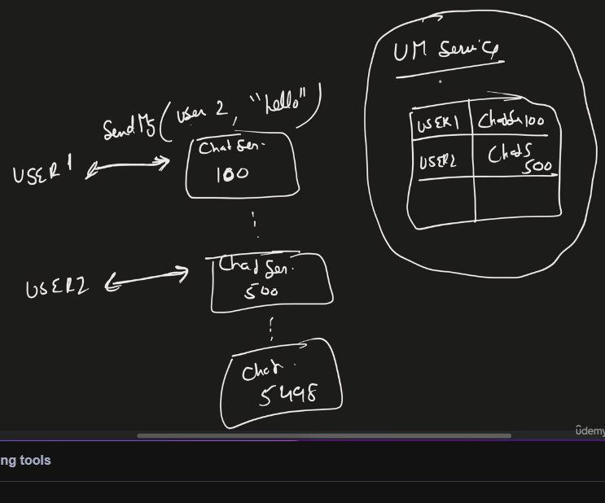

**1-1 Message Sending Flow**

* Suppose **User1** is connected to **ChatServer100** and **User2** to **ChatServer500**.
* To send a message from User1 → User2, **ChatServer100** needs to know which chat server User2 is connected to.

**User Mapping Service**

* Maintains real-time mapping of which **user is connected to which chat server**.
* Implemented using zookeeper (distributed coordination). It registers all the available chat servers and picks the best chat server for a client based on geography or load.
* Ex: User1 🡪 ChatServer100

User2 🡪 ChatServer500

* Use in-memory Redis to store active mappings.

**User Login Service**

* Handles user authentication and session creation when the user comes online.
* Communicates with the **User Mapping Service** to assign the most suitable chat server for that user.
* It has own DB (sql) storing all user data like address, phone no, username, etc.

**Message Flow**

* **User1** sends sendMsg(from, to, msg, type) request to **ChatServer100**.
* **ChatServer100** queries **User Mapping Service** to find where **User2** is connected.
* The service returns **ChatServer500**.
* **ChatServer100** forwards the message to **ChatServer500**.
* **ChatServer500** delivers the message to **User2** (if online) or stores it if offline.

**Chat History**

To maintain chat history, store offline messages, and support message search, we need a persistent, scalable database.  
The system must handle **billions of messages/day** with **low latency** and **high availability**.

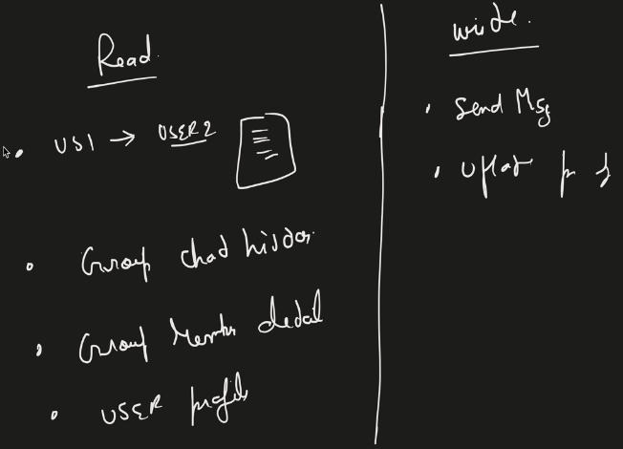

* We don’t see any complex query or Joins needed for these read operations.
* Lets say we want to search a word “concept” in all chats where it happened. So we need a low latency search capability in a very huge data.
* Our non functional requirements are highly scalable and highly available.

So all these give use hints for NoSQL database.

Discord and FB uses Cassandra DB (Column wise NoSQL)

For 1-1 flow, Message table looks like - 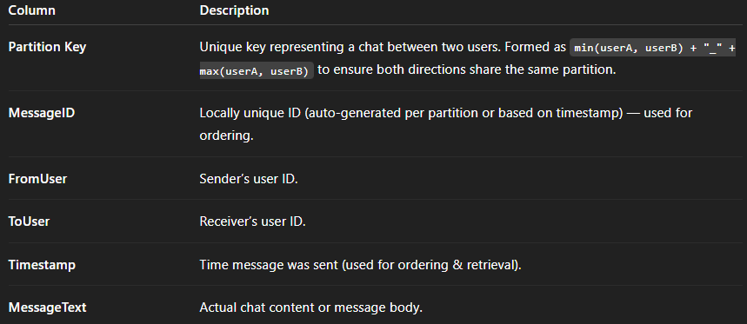

* A **partition** in NoSQL (like Cassandra) groups all related data (e.g., all messages in 1-1 chat) together on one node.
* Each chat (conversation between two users) is identified by a unique **partition key**.
* Each **partition** is stored on one node, determined by a hash of the partition key.
* Cassandra automatically distributes partitions across multiple nodes.  
  Ex- Partition Arjun_Krishna → Node 3

Partition Neha_Ravi → Node 5

Partition Ajay_Priya → Node 1

* Each node stores many partitions, but each partition’s data remains isolated.

partition_key = min(UserA, UserB) + "_" + max(UserA, UserB)

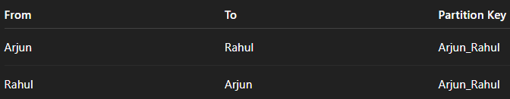

**Primary Key = Partition Key + Clustering Key**

**Clustering Key (MessageID or Timestamp)** orders data *within* that partition.  
→ Cassandra maintains sorted order of clustering keys.

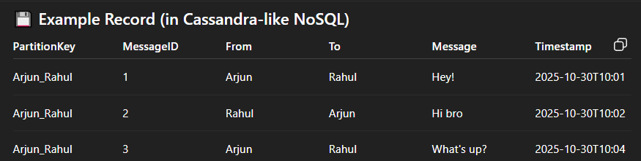

* All messages for one conversation live in one partition → easy to maintain order.
* Message ordering is handled by **MessageID** (or timestamp).
* Read queries (fetch chat history) become simple → just read from one partition.
* **For Message Ordering : NoSQL** doesn’t have auto-increment, so: Use **timestamp-based ID** (easy, ordered). Or use **local ID generator** per partition

**User Disconnection & Cleanup in User Mapping Service**

When a user **goes offline** (for example, closes the app, loses network, or disconnects from WebSocket), the **Chat Server** handling that user is responsible for cleanup.

**Steps :**

* The **WebSocket connection** between the user and the chat server closes.
* The **Chat Server detects disconnection** via WebSocket close event
* The Chat Server notifies the **User Mapping Service** to **remove the user’s entry**.
* The mapping (e.g., User1 → ChatServer100) is deleted.

**Offline Message Handling Flow**

**Scenario :**

* User1 → connected to ChatServer1
* User2 → connected to ChatServer2
* User Mapping Service maintains: User1 → CS1, User2 → CS2
* **ChatServer2 goes down** or **User2 loses internet**, breaking the WebSocket connection.
* User Mapping Service **removes the mapping** for User2.

**Message Sending During Offline :**

* User1 sends sendMessage(User2, "hello") via WebSocket to **ChatServer1**.
* ChatServer1 queries **User Mapping Service** for User2’s chat server.
* Since **no mapping exists** (User2 is offline), ChatServer1 cannot deliver the message in real time.
* **ChatServer1 stores the message** in the **database** (marked as *undelivered / pending*).

**User Reconnects :**

* When **User2** comes online again, and assigned **ChatServer3** by **User Mapping Service**.
* A new **WebSocket connection** is established between User2 and ChatServer3.
* **ChatServer3** checks the **Database** for any **pending messages** for User2.
* All undelivered messages are **fetched and pushed** to User2.
* After successful delivery, message status is updated to **delivered/read**.

**Group Message Flow**

**Data Storage Design :**

* **Group messages** are stored in a **NoSQL database** of Chat Server.
* **Partition Key:** groupId → ensures all messages of a group are stored together for efficient querying.
* Different groups are distributed across different database nodes (horizontal scaling across groups)
* **Message ID:** used to maintain **ordering** of messages within a partition.

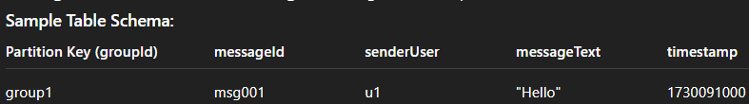

**Group Management Service:**

* Manages **group metadata** and **membership information**.
* Has its own **SQL/NoSQL database** that stores: Group ID, name, creation date, Member list, Admin info
* Handles group lifecycle actions: Create / Delete group, Add / Remove members, Join / Leave group

**Group Message Sending Flow :**

* **U1 → Group1 (U1, U2, U3, U4)**  
  U1 sends "hello" via WebSocket to **ChatServer100**.
* **Fetch Members:**  
  ChatServer100 queries **Group Management Service** → gets members [U1, U2, U3, U4].
* **Target Users:** Exclude sender → targets U2, U3, U4.
* **Find Chat Servers:** Query **User Mapping Service** →  
  U2→CS200, U3→CS300, U4→CS400.
* **Message Distribution:**  
  ChatServer100 forwards the message to CS200/CS300/CS400.  
  Each delivers it to its connected user via WebSocket.
* **Persistence & Offline Handling:** Message stored in **NoSQL (partitioned by groupId)**.

**Presence System (Last Seen / Online / Offline)**

**Heartbeat Mechanism:**

* Each **client (user)** sends a **heartbeat** to the **Presence System** at regular intervals (e.g., every 3 seconds).
* Presence System updates the user’s: status = online , lastHeartbeatTimestamp = currentTime
* User’s presence info is stored in KV store.

**Offline Detection:**

* If no heartbeat is received for a configured **threshold** (e.g., 1 minute), the system marks the user as **offline** and updates: status = offline, lastSeen = lastHeartbeatTimestamp

Communication between client and Presence system happens through WebSocket.

The **User Mapping Service (Zookeeper/Redis)** already tracks which user is connected to which Chat Server but it can’t be used for online/offline status because –

* imagine scenario: A user on a train enters a tunnel — network drops temporarily.
* Connection breaks (User Mapping sees offline), but a few seconds later, network restores and this happens multiple times.
* Status flips rapidly: **online → offline → online** — causing **bad UX**.

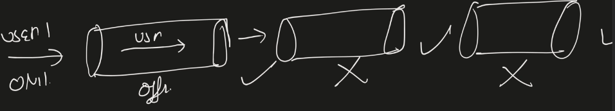

**Rate Limiter**

**What problem does a Rate Limiter solve?**

A **rate limiter** protects systems from abuse or overload by **restricting how many requests a user or client can make in a given time period**.

**Why it’s needed:**

* Prevents **DDoS attacks** and abusive behavior. Ex- If an attacker sends thousands of requests per second, the server’s resources may be exhausted, causing downtime. A rate limiter blocks excessive requests early, so genuine users are still served.
* Ensures **fair usage** of limited resources (CPU, memory, disk, bandwidth).
* Improves **system stability** under load.

**Different Algorithms**  
Token bucket, leaking bucket, fixed window counter, sliding window log, sliding window counter

**1) Token bucket**

there is a bucket which has certain properties like capacity - to hold token. If its 4 then it can hold 4 token maximum, if u try to add more token it will overflow.

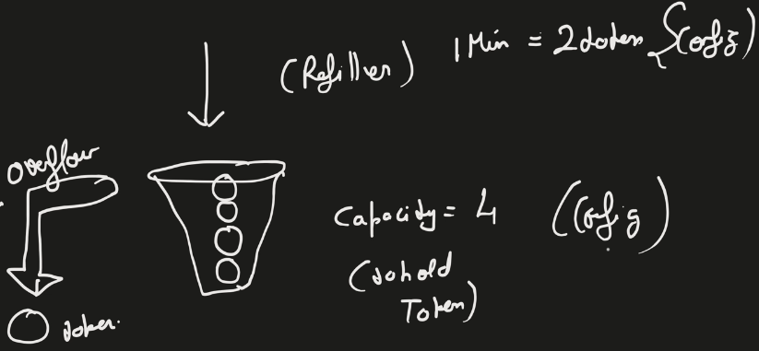

Refiller - to keep adding token after a particular time,  it has a property that in 1 min or 2 min how much token will it add. Lets say 1min = 2token . this is all driven by config file, we can change it . If the capacity is already full and refiller try to add token, then those tokens will overflow means they are removed.

whenever my request is coming, Token bucket algo will check if there is any token present? If YES then this request will consume that token. Suppose there were 3 token so after req consumes one, the count will become 2. Or else if there are no token then request will be denied.

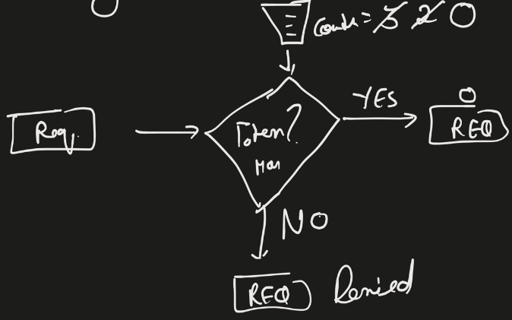

we can configure this token bucket per user. Ex- i can set rule that for each user :- 3 token per minute for tweet post  API and in 1 min refiller fill 2 token.

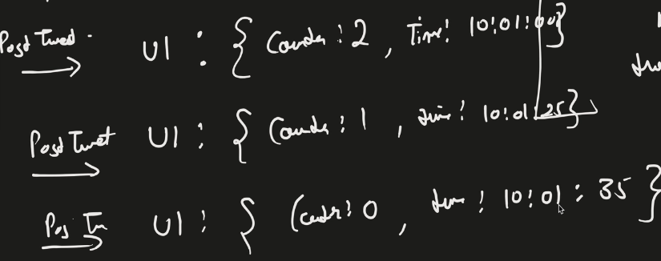

so for User1  now my post tweet api comes so the counter is reduced and it will put some timestamp when req came, U1 : { counter:2, timestamp : 10:01:00 }

suppose another post tweet req comes within 1 min ==> U1 : {counter:1, timestamp:10:01:25 }

another post tweet req comes ==> U1 : { counter:0, timestamp:10:01:35}

now another post tweet req comes within 1 min , now becoz counter is still 0 and refiller has not filled tokens so this request will get denied.

suppose no req comes for 2 minutes

now from 10:01 to 10:02 refiler added 2 tokens and after another minutes 10:02 - 10:03 refiller run and try to add 2 more tokens but the capacity is 3 so it can only add 1 token and 1 token will get overflow. So now counter is 3

now suppose another post tweet req comes at 10:03:10 ==> req is processes,

U1 : {counter:2, timestamp:10:03:10}

so this token bucket algo can be easily implemented using a counter. whenever any req is declined then http code returned is 429 Too Many Requests error.

**2) Leaking bucket**

There is one tap from req are coming (irregular flow) and the bucket has fixed capacity. And out of the requests which are coming in bucket there is a leak in bucket at constant rate. And leaked requests are processed.

If the incoming req are more than what we are processing, then there will be overflow and that request are denied.

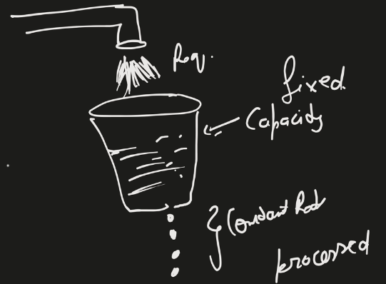

It is implemented through queue.

Suppose req is coming for I will do a check if Queue if filled? If no it will push the req in FIFO form and it will processed at constant rate. If Queue is full then req is denied with HTTP code 429.

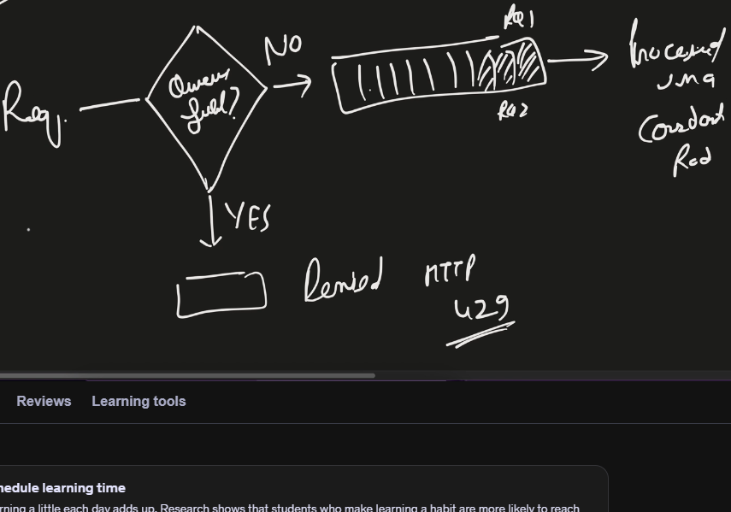

Drawback :- there are certain applications in which a constant burst can come. Ex- Amazon prime – maybe during day time the traffic is not much as compared to evening or night.

**3) Fixed window counter**

It divide time into particular time limit. Lets say 5 mins timeframes. Each time frame is a fixed window and each window has a counter. (configurable)

So when a req comes within the fixed window timeframe, it will use the counter and reduce it by 1. If counter becomes 0 and req try to come in that window, then it will be denied.

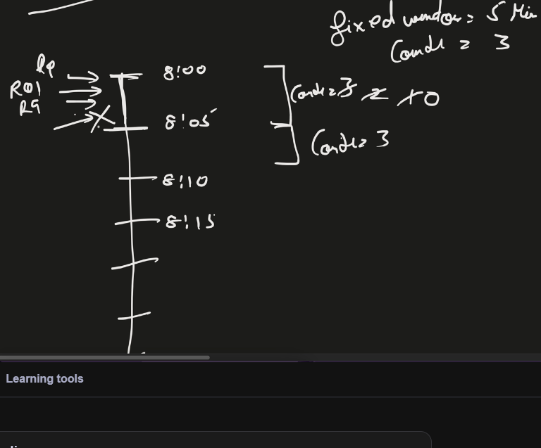

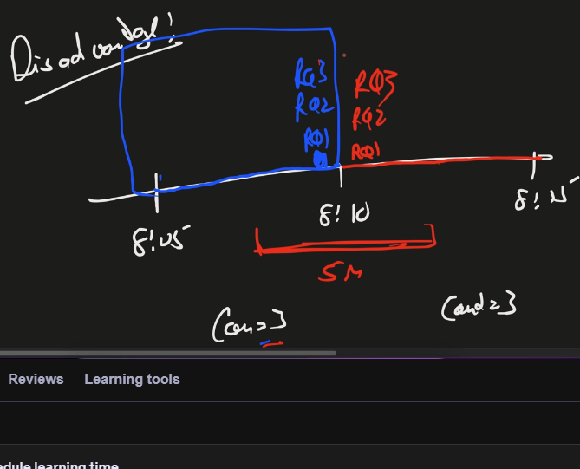

Drawback :- In scenario when all req comes just before time frame ends and just after new time frame starts., then the no of req load might get double and our system may not be ready for it. This problem is solved by Slidind window log.

**4) Sliding Window Log**

In this is no fixed size window. Here we keep a log of timestamp at which req came.

Suppose my configuration is 3 Requests/minute so I will have a sliding window of 1 min from the first req time and it will allow 3 req after that time.

Suppose Req1 comes at 10:00:10 , req2 comes at 10:00:20 , req3 comes at 10:00:40 alll three will be processed as comes within 1 min and 3 requests are allow in 1 min. Their timestaps are stored in sorted manned. But when req4 comes at 10:00:45 then this will be declined but algorithm will log this one.

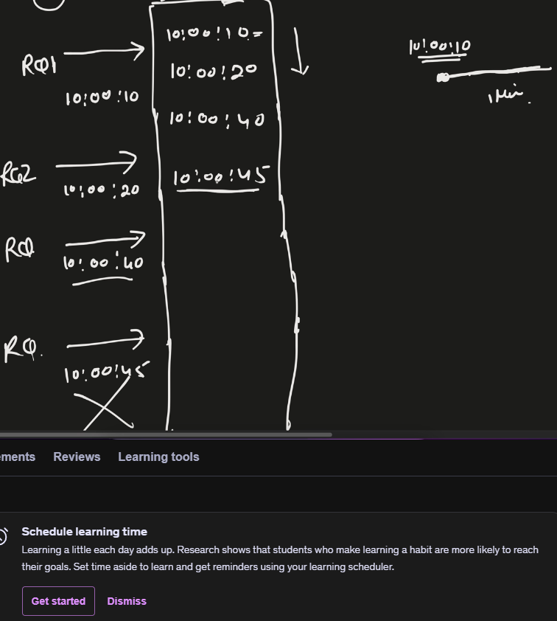 size = 1 -> 2 -> 3 -> 4

Suppose now Req5 comes at 10:01:20, now the window will slide as it started with 10:00:10 and 1 minute has passed. From the top sorted timestamps, it will remove till it comes into window.

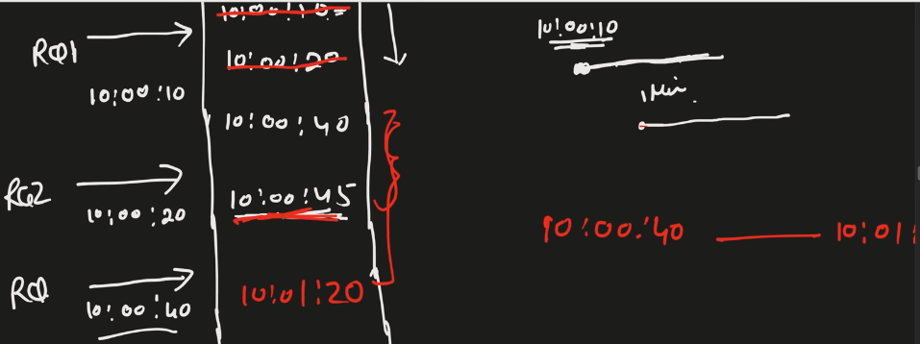size = 4 -> 3 -> 2 -> 3

Two timestamps – 10:00:10 , 10:00:20 are removed.

Disadvantage – even the req is denied but we are still storing its log. memory issue

**5) Sliding Window Counter**

It adds two functionality – fixed window counter + sliding window log and takes advantage of both of them.

It is memory efficient.

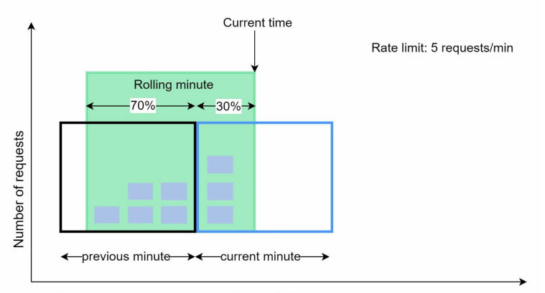

Assume the rate limiter allows a maximum of 7 requests per minute, and there are 5 requests in the previous minute and 3 in the current minute.

No req in sliding window = Requests in current window + requests in the previous window * overlap percentage of the rolling window and previous window

3 + 5 * 0.7% = 6.5 request. Since the rate limiter allows a maximum of 7 requests per minute, the current request can go through.

Drawback :- it assumes requests in the previous window are evenly distributed

**HLD Design**

Components –

* We use counter so need Redis to fast update it.
* We store config file

Benefits of using Redis – centralized data store. Multiple rate limiters instances can use the same Redis.

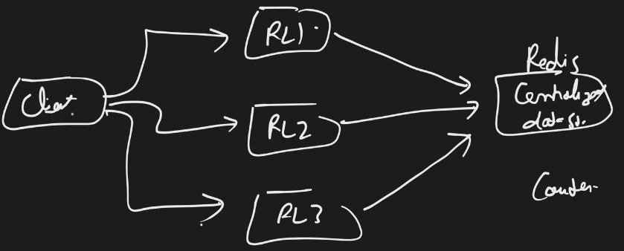

If client sends the request to server and there is no gateway in mid then we can host the rate limiter algorithm in server itself.

If there is something like API Gateway in between which do authentication and all, we can put rate limiter algorithm there.

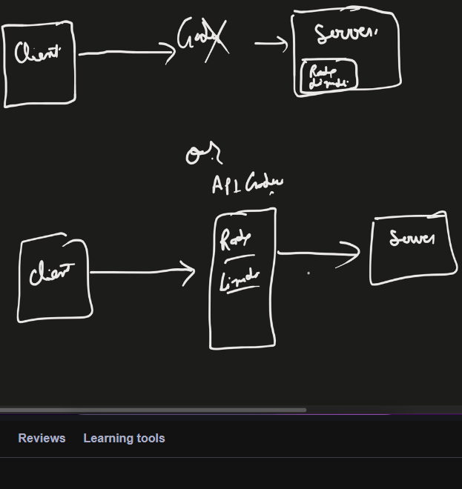

Config files are stored on the disk, but they are not frequently changed so will also use Cache to store file there for fast access after loading from the DB.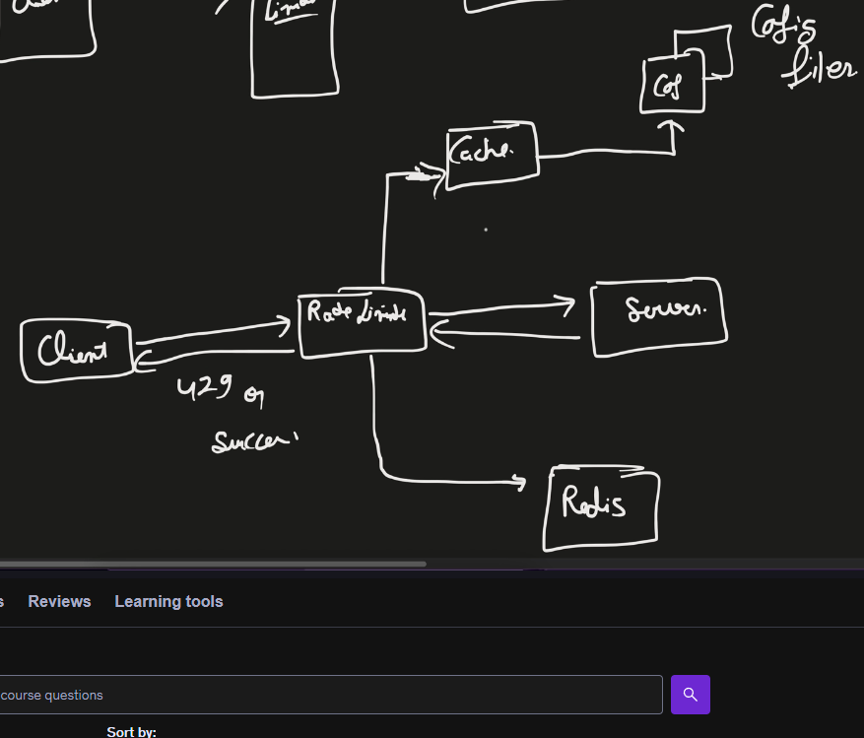

**Proxy Server**

Ex- Child wants a chocolate. So he will ask his mom for chocolate. Mom goes to the shokeeper and buy the chocolate and gives it to her child. So here **mom takes the request on behalf of child** so she acts as a Proxy for shopkeeper.

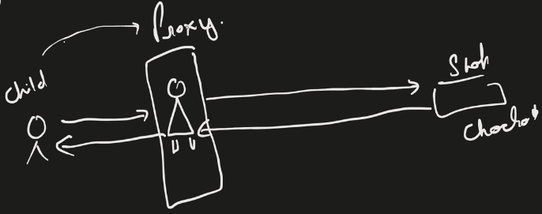

* Proxy server sits between client and server and acts as an intermediate between these two.
* It can take requests from more than 1 client also.
* All the requests passes through the proxy server. No client & server can directly talk to each other.

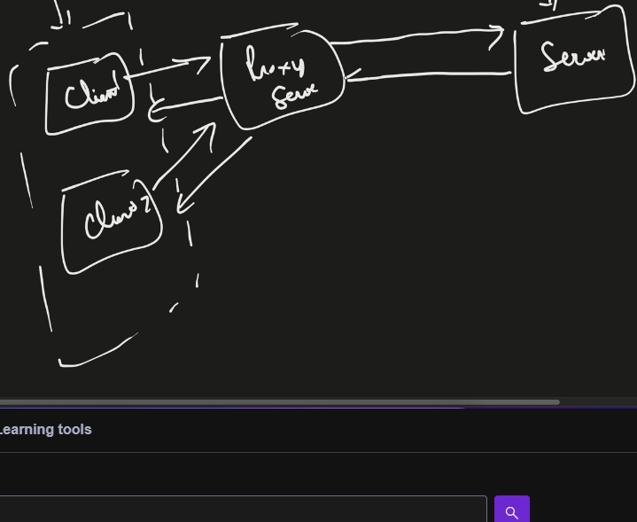

Different types –

**1) Forward Proxy**

* A group of clients talks to Proxy
* Forward proxy now goes to the internet outisde world. It reach out to a particular server.
* The server responds back and proxy returns the response to client.

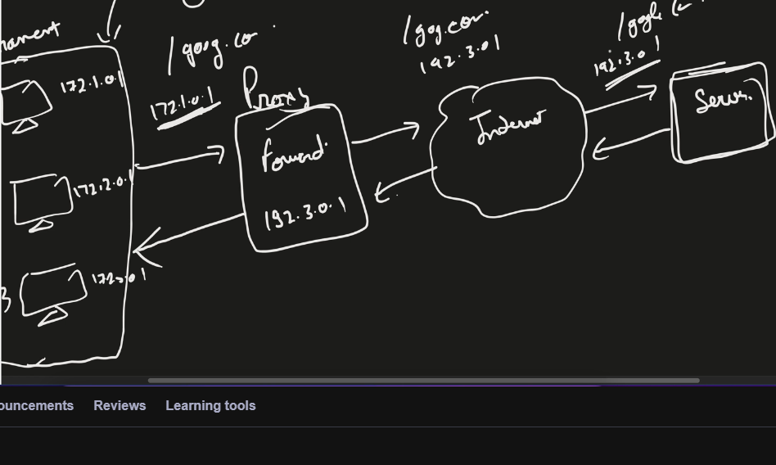

Forward Proxy hides the client network means Server in outside world don’t know about internal clients.

* Ex- Suppose client with ip address 172.1.0.1 sends the request to proxy, then proxy will send its own IP address to the outer world.
* No server can talk directly to the clients.

**Benefits –**

* **Clients are anonymous** to destination server
* **Grouping of requests** – Proxy can club similar requests coming from multiple clients and send a single request to server.
* **Access restricted data/content** – suppose your country has banned particular websites but with the help of proxy you can bypass those.

Ex- client from IN but proxy server used is from UK or US from where those websites are accessible. When request from IN client passes throught proxy, it can act as if coming from some other location.

* **It brings Security** – as requests from multiple clients goes through the Proxy so we can put logic in Proxy like what all info/data the clients are allowed to access. We can add certain rules based checking and bring some control.
* **Caching** – you can also do caching of certain static content. Ex- Suppose there is a request to access website A, now proxy will check first in its cache for static content of the site. If not present then it goes outside. Once it gets the response, it will store into cache. Now if any other clients ask for the same content, the proxy sever will respond from cache itself.

**Drawbacks –**

* It works on application level. Means if there are 10 applications you have to setup a proxy for each of them.

**2) Reverse Proxy**

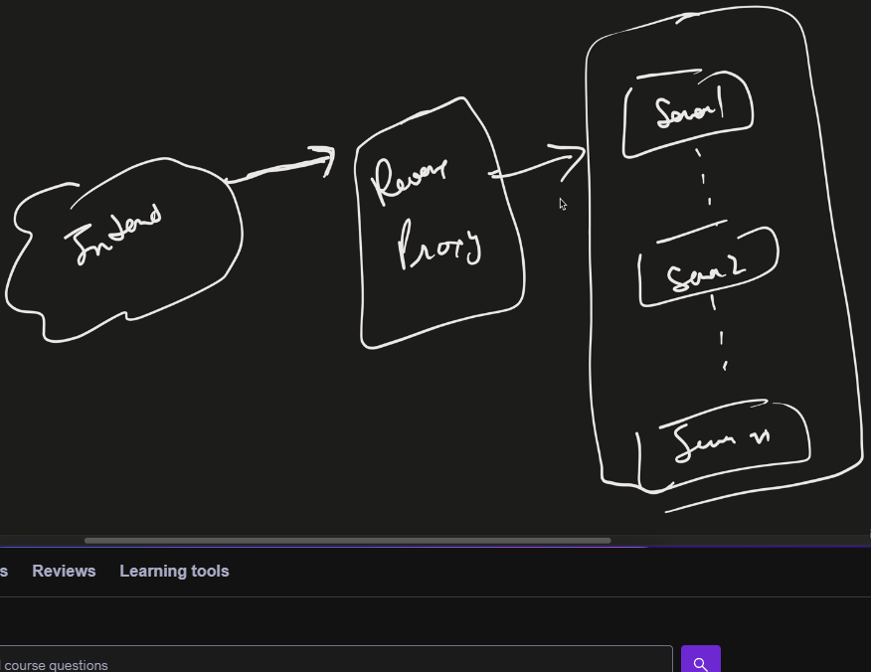

Requests coming from Internet can’t talk directly to the server. Request first has to go through reverse proxy talks to the server. Ex- CDN

Benefits –

* **It brings security** as the outside world is not aware of the Server’s IP address. All they are aware of Reverse proxy IP. Incase of DDoS attack attackers can’t attack the Servers and reverse proxy can handle it.
* **Caching** – in case of CDN when user makes request it first goes to CDN and if data is present in cache then it will return from there otherwise it goes to original server and store in cache.
* **Latency** – reverse proxy can sit near to the user location. Ex- in CDN request first goes to nearest CDN node.
* **Load Balancer** – when a request comes in, it can do load balancing task also.

**Proxy v/s VPN**

* Proxy acts as a bypass. It generally help to bring anonymity(hides the IP address), caching, etc.
* VPN is much more than proxy. If client has taken VPN, then there will be VPN client and VPN server and a VPN tunnel is created between them. So when a client makes a request, first it has to connect to a VPN client. VPN client can do encryption of your data so all request goes as encrypted data through VPN tunnel. So from outside if any attacker tries to access the data, it will not be able to know. VPN server it will do decryption and send it to the original server.
* Proxy cannot do encryption/decryption.

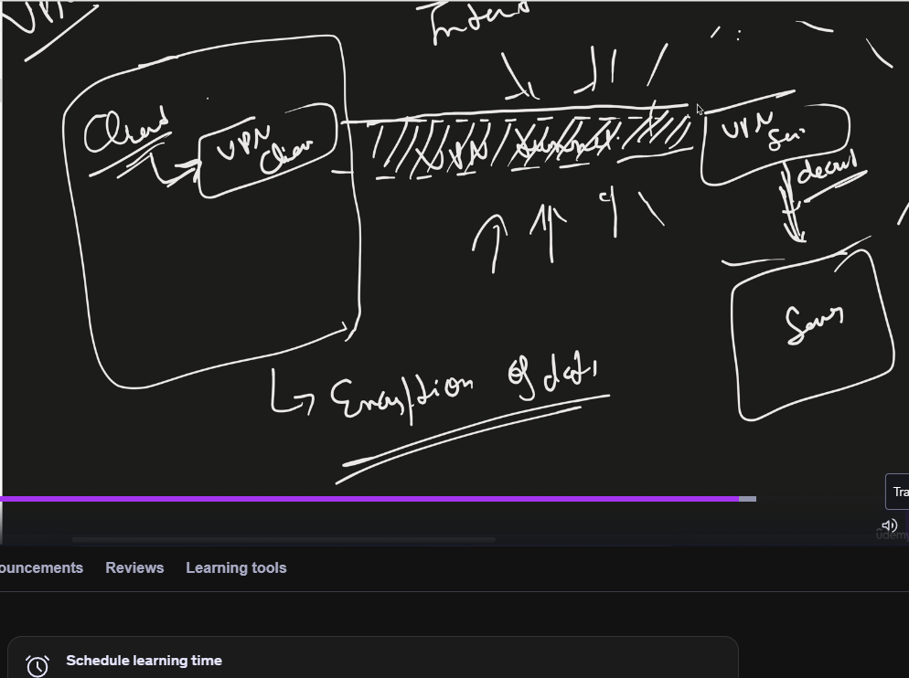

**Reevrse Proxy v/s Load Balancer**

* Reverse Proxy can act a Load Balancer.
* Load Balancer cannot be a proxy.
* If there is only 1 server u don’t need LB but RP might be needed.

**Proxy v/s Firewall**

* In the firewall we put some holes and for each hole, we can define the rules like from this hole what all data can pass to the outside world.
* Firewall can do packet scanning (works on Network, Transport layer). It will check the header, port no, ip address of source and destination. And based on that it will check the rules whether I should allow it or not. So it blocks certain requests.
* Proxy works on Application layer. You have access to application data (paylaod) as well as networking metadata like IP or ports.
* Proxy was initially designed for anonymity and caching, but modern proxies can also filter and block based on content or rules — acting as application-layer firewalls.

**Load Balancer**

When requests come from multiple clients, all requests should not go to 1 server so we put Load Balancer. Main purpose is to distribute the traffic appropriately to all the servers so that no one single server get overburden.

**Types –**

* **Network Load Balancer (L4 Balancer)** – it can read IP address, TCP port/ UDP port (much faster)
* **Application Load Balancer (L7 Balancer**) – it can read your header, session, application data, cookies. It can also do caching as it read the response. (much more advanced)